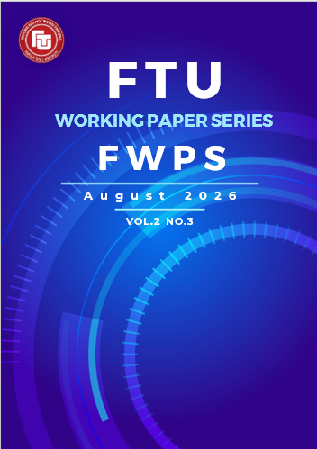
Working Paper 2026.2.3.11
- Vol.2, No. 3

NGHIÊN CỨU KHÁM PHÁ VỀ CƠ CHẾ NỘI DUNG VÀ TIẾP THỊ NGƯỜI ẢNH HƯỞNG TRÊN TIKTOK: NGHIÊN CỨU ĐIỂN HÌNH TẠI VIỆT NAM

Nguyễn Bằng Lan Anh
Sinh viên K63 CLC Quản Trị Kinh Doanh Quốc Tế
Phân hiệu Trường Đại học Ngoại thương tại TP. Hồ Chí Minh

Lê Đức Huy
Sinh viên K60 ĐTQT Quản Trị Marketing
Phân hiệu Trường Đại học Ngoại thương tại TP. Hồ Chí Minh

Tóm tắt
Những người có sức ảnh hưởng trên mạng xã hội đóng vai trò quan trọng trong việc thúc đẩy hiệu suất thương hiệu thông qua quảng bá sản phẩm và dịch vụ trên các nền tảng số. Khung phân tích được đề xuất nhằm xem xét các yếu tố dựa trên nội dung ảnh hưởng đến hiệu suất của các nhóm người có sức ảnh hưởng khác nhau trên TikTok. Phương pháp nghiên cứu tích hợp phân tích mô tả, phân tích cảm xúc, phân tích nội dung và phân tích mạng để khám phá mối quan hệ giữa thuộc tính nội dung và chỉ số tương tác. Bộ dữ liệu bao gồm 4.052 video được đăng tải và 96.534 bình luận thu thập từ 51 tài khoản của Influencer bằng công cụ dữ liệu Apify từ ngày 1 tháng 1 năm 2024 đến ngày 30 tháng 6 năm 2025, tập trung vào các lĩnh vực Làm đẹp, Thời trang và Thể thao. Mô hình ViSoBERT được tinh chỉnh được sử dụng để xác định cực tính cảm xúc trong các bình luận tiếng Việt liên quan đến video quảng cáo. Kết quả cho thấy sự khác biệt đáng kể về hành vi người có sức ảnh hưởng, đặc trưng video và mức độ tương tác khán giả, đồng thời nhấn mạnh mối tương quan chặt chẽ giữa chỉ số tương tác và siêu dữ liệu video như sử dụng từ ngữ liên quan cảm xúc và hashtag. Các phát hiện này làm phong phú thêm hiểu biết về động lực nội dung trong Influencer Marketing và cung cấp hàm ý thực tiễn cho việc tạo nội dung hiệu quả trên các nền tảng mạng xã hội.
Từ khoá: Influencer, phân tích dữ liệu mạng xã hội, Influencer Marketing, Tiktok, Việt Nam

AN EXPLORATORY CONTENT ANALYSIS OF INFLUENCER MARKETING ON TIKTOK: A CASE STUDY OF VIETNAM

Abstract
Social media influencers (SMIs) play a crucial role in driving brand performance through the promotion of products and services on digital platforms. An analytical framework is proposed to examine content-based factors influencing the performance of different influencer categories on TikTok. The research approach integrates descriptive analytics (DA), sentiment analysis (SA), content analytics (CA), and network analytics (NA) to explore the relationship between content attributes and engagement metrics. The dataset consists of 4,052 published videos and 96,534 comments collected from 51 influencer accounts via Apify scraping between January 1, 2024, and June 30, 2024, focusing on the Beauty, Fashion, and Fitness sectors. A fine-tuned ViSoBERT model is employed to determine emotional polarity in Vietnamese-language comments associated with promotional videos. The results reveal notable differences in influencer behavior, video characteristics, and audience engagement, while highlighting significant correlations between engagement metrics and video metadata such as sentiment-related word usage and hashtag utilization. These findings enhance the understanding of content dynamics in Influencer Marketing and provide practical implications for effective content creation on social media.
Keywords: Influencer, social media analytics, Influencer Marketing, TikTok, Vietnam

1. Introduction
Social media influencers (SMIs) have become critical players in the new digital marketing environment, as they have radically changed the way information is distributed and how consumers make choices in the online communities. With the emergence of more and more skeptical and resistant audiences to conventional advertising formats, Influencer Marketing has established itself as one of the most effective strategies in reinforcing brand presence, creating trust, and triggering purchasing intentions (Elberse and Verleun, 2012; Walternath et al., 2022; Dadvari, 2023). Although it has been shown that the influence-specific qualities, including trustworthiness, expertise, and physical attractiveness, are major drivers of audience attention (Tzoumaka et al., 2016), content-level mechanisms that predetermine the success of influencer-created messages in converting them into different levels of engagement have not been studied extensively, both theoretically and empirically.
The successful short-form video structure, along with its advanced, algorithm-based content distribution, has enabled TikTok to gain a stronger foothold in the Influencer Marketing field significantly, especially among younger audiences. The existing research in the context of TikTok has mostly focused on the overall influencer features and the overall success of endorsements (Chung and Cho, 2017; Li and Sun, 2024; Chen and Lu, 2024). Nonetheless, the deficit of empirical studies that thoroughly break down the content-specific features is still a significant issue, most notably the relative success of the performance of organic and sponsored influencer content. Moreover, the current academic literature is strongly skewed towards the Western markets, and emerging economies such as Vietnam have very little empirical coverage in spite of growing, youth-based digital populations.
To address these critical gaps, this study employs a rigorous content-analytic approach to investigate TikTok Influencer Marketing within the Vietnamese context. By focusing on the high-growth sectors of Beauty, Fashion, and Fitness, this research analyzes a comprehensive dataset of influencer videos over a six-month period to evaluate how specific content attributes, audience sentiment, and sponsorship status interact to shape engagement. Through the integration of descriptive analytics, sentiment analysis, content analytics, and network analytics, this study provides much-needed empirical evidence to the field of Influencer Marketing and extends the theoretical understanding of content effectiveness on short-form video platforms within an emerging market framework.
2. Literature review
2.1. Theoretical Framework
2.1.1. Source Credibility Theory
The theory of Source Credibility was introduced by Hovland et al. (1953) and it is based on the idea that the perceived attributes of a communicator are crucial in determining how persuasive a message would be. Within the framework of TikTok, credibility is a multi-dimensional concept that includes expertise (Beauty, Fashion, or Fitness knowledge), trustworthiness (be honest when reviewing products), and attraction (aesthetic appeal). This paper applies this framework to the analysis of how these perceived attributes expressed by the use of video metadata and content style can be converted into measurable engagement outcomes such as likes and shares.
2.1.2. Parasocial Interaction (PSI) Theory
Parasocial Interaction is a one-way, the pseudo-social type of relationship that the users of media establish with the on-screen characters. The close nature of the content on TikTok and the adoption of a direct-to-camera style of storytelling encourage a sense of intimacy and the feeling of friendship between influencers and their followers. The hypothesis presented in this study is that the increased the levels of PSI, the more authentic the recommendation and less resistance to sponsored content, as the followers perceive the recommendation given by the influencer as a piece of advice by a peer who is trustworthy but does not appear as a commercial ad.
2.1.3. Affective Intelligence and Emotional Contagion
The engagement dynamics on TikTok are further explained by the role of emotional resonance. According to the principles of emotional contagion, users are likely to “catch” and respond to the high-arousal emotions (humor, inspiration, or excitement) displayed in influencer videos. By employing Sentiment Analysis (ViSoBERT), this research explores how positive emotional polarity in both video content and audience comments serves as a catalyst for viral dissemination and sustained interaction.
2.2. Influencer Marketing and content credibility
Influencer Marketing has emerged as a powerful digital marketing tactic because it has the ability to create parasocial relations and a sense of authenticity between influencers and audiences. Previous studies consistently show that the content created by an influencer increases brand awareness, attitudes, and purchase intentions, especially when viewers think that they can trust and connect with the influencer (Kapitan et al., 2021; Lou and Yuan, 2019). According to the source credibility theory, the credibility, expertise, and attractiveness have a combined effect on the endorsement effectiveness (Hovland et al., 1953; Tzoumaka et al., 2016). These dimensions of credibility have a strong connection to content design in the case of short-form video platforms, like TikTok, in visual presentation, content style and emotional resonance (Gan et al., 2023; Kay et al., 2022).
2.3. TikTok's algorithm and engagement dynamics
The recommendation system in TikTok is one of the key components of the platform that is mainly implemented by the For You Page (FYP) and defines content visibility and interest. The platform uses the signals of the interaction with users to show them the content optimally, i.e. time of viewing, likes, comments and shares to market the videos outside the range of the current followers of an influencer (Schellewald, 2021; Cheng et al., 2022). With the help of such an algorithm, well-known and even novice influencers can gain viral coverage when the content appeals to the audience.
Emotional intensity is a very relevant aspect of the engagement dynamics of TikTok. The videos that provoke humor, inspiration, or other affective emotions are more likely to get increased interaction and algorithmic boosts (Indrawati et al., 2023). Therefore, participation in TikTok does not entirely rely on the position of influence but rather heavily relies on content and emotional appeal.
2.4. User engagement and sponsored content
User engagement serves as a primary indicator of influencer performance and audience response on social media platforms (Yew et al., 2018). Engagement metrics, including likes, comments, shares, and saves, reflect both content relevance and relational strength between influencers and their followers (Van Driel & Dumitrica, 2021). Prior studies highlight systematic differences between organic and sponsored content, suggesting that while sponsored posts may increase visibility, they often generate lower engagement due to reduced perceptions of authenticity (Kay et al., 2022; Evans et al., 2018).
Within the TikTok context, the balance between promotional and non-commercial content is particularly critical. Audiences tend to favor influencer content that integrates brand messages organically into storytelling formats rather than overt advertising, reinforcing the importance of content authenticity in sustaining engagement.
2.5. Utilizing TikTok for Influencer Marketing
Zhang et al. (2023) and Nurjannah and Surianto (2022) examined TikTok’s impact on brand recognition and purchasing preferences of consumers because this emerging Influencer Marketing platform brings together content-specific features with huge user participation. Consumer perceptions and behaviors regarding TikTok Influencer Marketing continue to be influenced significantly by three proven elements including credibility and expertise together with attractiveness (Handranata et al., 2024; Tartaraj et al., 2024). Indrawati et al. (2023) discovered that user-generated content serves as a vital force in constructing trust together with modifying consumer actions on TikTok because authentic and relatable material activates enhanced consumer trust and engagement.
3. Methodology and data collection
3.1. Data collection
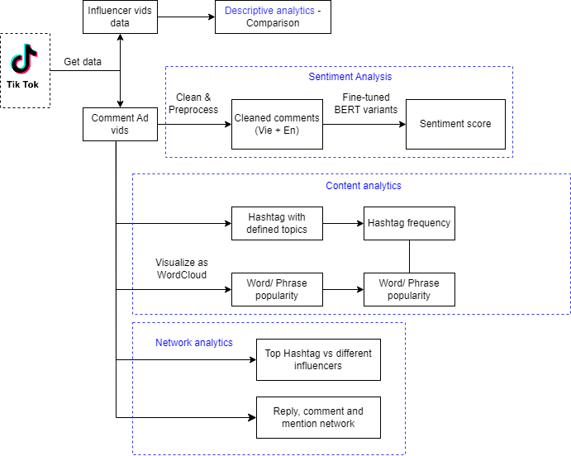
Figure 1: Conceptual framework of research
Source: Authors' compilations

The research obtained TikTok videos and comments through the Apify platform, between January 1st, 2024 and June 30th, 2024. Apify represents a commonly used research method for extracting social media data as reported by Marti-Ochoa et al. (2024) and Wu et al. (2023), and it delivered all required functions. The “TikTok Profile Scraper” API allowed us to download videos together with their attributes by focusing on Beauty, Fashion and Fitness content identified through news reports. Through the “isAd” field set to “True” value, we extracted advertised content from the filtered videos. The API for TikTok Comment Scraper allowed us to gather all comments present in these advertisement videos. The commented data serves vital purposes for sentiment evaluation and network analysis which helps identify user behavior and promotional interactions inside selected TikTok areas. The steps we utilized for our data gathering and processing as described in Table 1 consisted of eliminating non-Vietnamese videos, while also reducing noise levels that enabled model refinements of a pre-trained sentiment analysis and network analytics examination.

Table 1: Overview of dataset aspects and descriptions
Source: Authors' compilations
Aspect | Description
Data Source | - Apify Scrapper Platform  - Data types: Influencer videos and comments on TikTok
Time Period | January 1, 2024 - June 30, 2024
TikTok Data | 4,052 videos and 96,534 comments on advertising videos. 51 influencers (18 Beauty Influencers, 22 Fashion Influencers, 11 Fitness Influencers)
Data Scope | Beauty, Fashion, and Fitness Field
Dataset Attribute | - Video dataset: author information, posting time, number of saves, number of hearts, number of comments, number of shares, hashtags  - Comment dataset: creating time of comments, username, comment, heart reaction of comment, reply or comment
Data  Pre-processing | - Filter Vietnamese comments  - Lowercase and remove unnecessary parts (URLs, hashtags, mentions, irrelevant characters)  - Rewrite or expand the acronyms and misspelt words by creating a dictionary.
Cleaned data | 88,983 Vietnamese cleaned comments (69,013 Beauty comments, 18,971 Fashion comments, 999 Fitness comments)
Fine-tuning | Manually annotate 1,490 comments in three fields and fine-tune model
Word and Hashtag analysis | - Use RDRSegmenter to generate the word segment  - Extract the hashtags, and classify hashtags into topics: Event, Brand, Product, Location, Slogan, Influencer, and Others  - Remove the stop words or irrelevant words  - Use Wordcloud to present the frequency of occurrence of words
Reply and comment network | Use directed network and graph metrics to explore the influencer popularity

3.2. Data analytics
3.2.1. Descriptive Analytics (DA)
The research applied Descriptive Analytics (DA) to discover patterns and relationships between quantitative metadata items. The data science tool helps to obtain intelligence while displaying influencer characterization metrics and analyzes both organic and sponsored video engagement figures (heart counts, comment counts, reaction counts) as well as hashtag and mention data.
An influencer’s performance gets evaluated through audience behaviour when viewing posted content. This study uses the engagement rate formula from (Yew et al., 2018) to calculate engagement percentages which evaluate post-performance relative to follower count without prejudice. The focus of this research is to discover which posts achieve the maximum engagement but to develop the formula we included all relevant success indicators (Alonso-López et al., 2023). The engagement rate calculations stem from video view count data alongside heart counts and comment counts alongside save counts and share counts. This paper employs the following formula to evaluate TikTok post-engagement rates:
Engagement rate (%) = 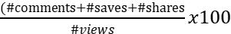
3.2.2. Sentiment analysis
The analysis of sentiment acts as a text evaluation method for identifying positive, negative or neutral sentiment (Mehta and Pandya, 2020). The technique helps identify the author’s feelings and viewpoints towards certain subjects which guide important decisions. The three levels used for analysis cover sentence level alongside document level and aspect or feature level under investigation. Social media users express sentiment through video titles alongside thumbnails as well as captions and audience-generated comments (Cui et al., 2024). This research analyzes video captions together with audience comments using ViSoBERT to retrain the model with our provided dataset for sentiment classification.
3.2.3. Content analytics
The research adopts RDRsegmenter as its Vietnamese word segmentation method that Dat et al. (2017) introduced to extract meaningful phrases. The word cloud displays term frequency through visual word scale representation that mirrors word occurrences in provided texts. To remove the extraneous words, we implemented a rule-based dictionary through which we properly tokenized all single terms before developing the WordCloud function in the Python application for words and hashtags. The size progression indicates the amount of times a word appears within an input message suggesting its elevated level of significance. Hashtags serve as a fundamental element in social media data since they act the same way as interest fields and enable post categorization across multiple topics. The research team manually linked hashtags to specific topics to analyze how video topics occurred.
3.2.4. Network analytics
Video engagement level and dissemination activities on TikTok become apparent through the comments and mentions interactions. Data extraction of network information from the comment database requires implementing techniques and metrics derived from network theory. Our research built directed weighted networks based on influencing advertisements in which we analyzed three main engagement elements which included replies comments and mentions. The topology received a group-based clustering treatment for visualization reasons. The Clauset-Newman-Moore (CNM) algorithm in the NodeXL tool (Clauset et al., 2004) carried out cluster analysis to identify related vertices through their structural characteristics. The CNM algorithm represents a heuristic solution to discover communities among extensive network systems. The analysis begins by designating every vertex as its individual cluster yet perpetually joins two vertices to generate bigger clusters. The generated directed weighted network received its visual representation through the Harel-Koren Fast Multiscale layout algorithm after cluster processing.
4. Research results
4.1. Influencers and video characteristics
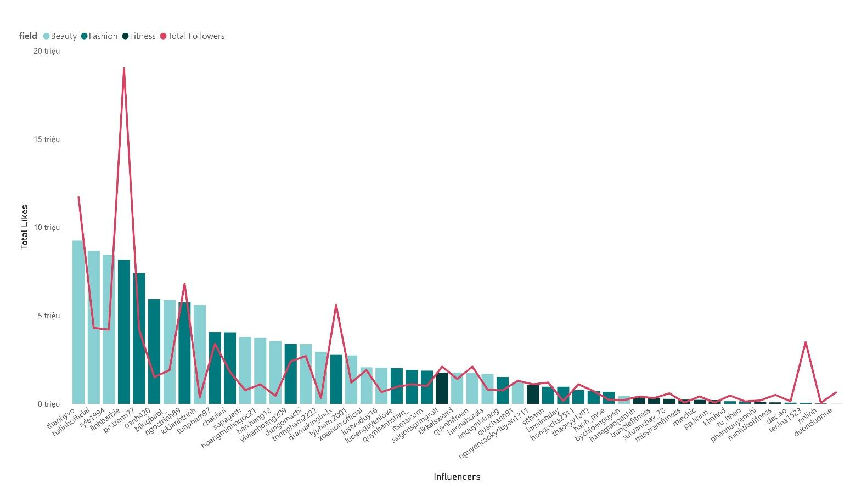
The research results show how different fields split between male and female influencers. The majority of influencers who are women choose fields such as Beauty at 84.2% and Fashion at 91%, and Fitness at 82%. The Beauty and Fashion sectors demonstrate the most packed total statistics when it comes to likes and followers. The gathered statistics show the full dataset beginning from data collection initiation until the present day. The engagement levels of influencers whose follower counts are low tend to be higher when observed through the total hearts metric. A large number of followers does not lead necessarily to better performance according to this study. Aside from audience size, influencers generate impact through audience engagement levels (De Veirman et al., 2017).

Figure 2: Overview of Influencer statistics
Source: Authors' compilations

Results indicate substantial variation in engagement across sectors, with Beauty and Fashion influencers consistently outperforming Fitness influencers in terms of likes, comments, and shares. Notably, influencer follower count was not a reliable predictor of engagement, as several accounts with moderate audience size achieved disproportionately high interaction levels. Sponsored content constituted a relatively small proportion of total output, suggesting that influencers selectively integrate paid partnerships rather than relying on continuous promotional posting.
Posting time analysis reveals that engagement peaks during evening hours, aligning with leisure-oriented usage patterns. Content published during early morning or late-night periods generally exhibited lower interaction rates, underscoring the strategic importance of temporal optimization.
Table 2: Characteristics of TikTok videos in our dataset
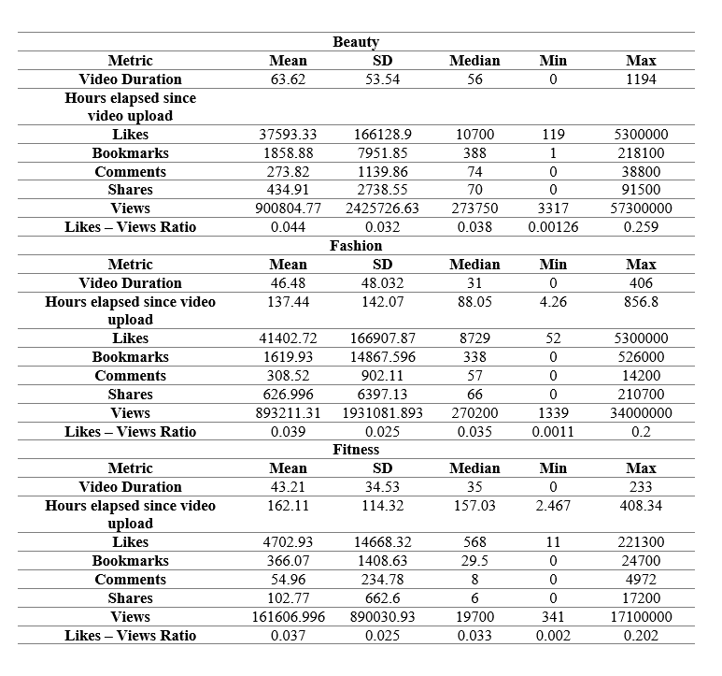
(Source: Authors' compilations)

The analysis reveals marked disparities between total video output and sponsored content across the three sectors, reflecting heterogeneous influencer endorsement strategies on TikTok. Sponsored videos account for only a limited proportion of overall content production, indicating that paid partnerships are selectively integrated rather than dominant. Beauty and Fashion influencers demonstrate a higher propensity to engage in brand-sponsored campaigns compared to those in the Fitness sector, where endorsement activity remains minimal even among highly active creators. Importantly, the proportion of sponsored content varies substantially across influencers and is not directly associated with total posting volume, suggesting that monetization strategies are shaped more by influencer positioning and content orientation than by activity intensity. Several influencers prioritize self-promotion, entertainment, or personal branding over third-party endorsements, underscoring the diversity of commercialization practices within the TikTok influencer ecosystem.
In parallel, posting time analysis identifies clear temporal patterns in influencer behavior and audience interaction. Influencers predominantly publish content during late evening and early night periods, particularly within the Beauty and Fashion sectors, aligning with peak user activity windows. Posting frequency declines sharply during early morning and late-night hours, indicating reduced effectiveness for audience reach. These temporal dynamics correspond with broader social media usage patterns, whereby users engage more actively during leisure periods following daytime obligations. Engagement levels tend to diminish for content posted at the beginning and end of the daily cycle, highlighting the strategic importance of temporal optimization in maximizing interaction. Overall, these findings are consistent with prior evidence on time-dependent engagement behavior and reinforce the role of posting schedules as a critical factor in Influencer Marketing performance on TikTok.
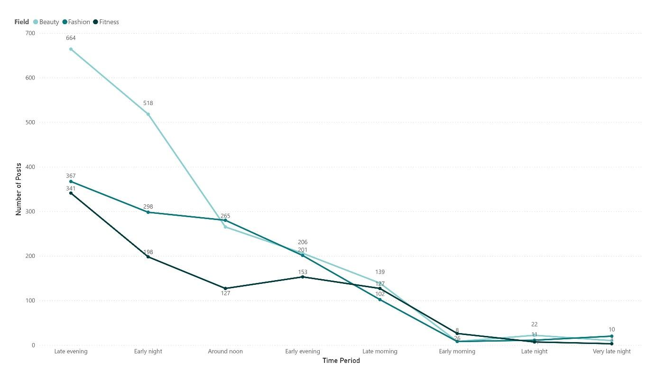

Figure 3: Favourite local times for posting
Source: Authors' compilations
4.3. Engagement rate patterns
Influencers were classified into micro, macro, and mega categories based on follower thresholds commonly adopted in prior studies (Britt et al., 2020; Cruz et al., 2024). The sample comprised predominantly macro and mega influencers across the Beauty, Fashion, and Fitness sectors, reflecting the platform’s professionalized influencer landscape.
Overall, mega-influencers achieved the highest engagement rate (123%), followed by macro-influencers (91%), while micro-influencers exhibited substantially lower engagement (12%). Sector-level analysis indicates that mega-influencers in Beauty and Fashion generated considerably higher engagement than those in Fitness. Among macro-influencers, Fashion outperformed Beauty and Fitness, whereas micro-level engagement was observed only within the Fitness category. These findings suggest that both influencer scale and sectoral context jointly shape engagement outcomes on TikTok.
With respect to posting time, engagement rates varied systematically across time periods. Across all sectors, engagement peaked during nighttime hours and declined during late-night and early evening intervals. Fashion and Fitness sectors exhibited engagement decreases during early evening, whereas Beauty experienced a modest increase. Sector-specific variations were also observed, with Fashion achieving its highest engagement around noon, while Beauty and Fitness peaked during nighttime periods. These results highlight the importance of temporal alignment with audience activity patterns in optimizing engagement performance.
The comparison between organic and sponsored content reveals that organic videos consistently outperformed endorsed content across all sectors. Although paid videos still generated substantial engagement, their performance remained lower relative to organic posts, with the largest engagement ratio observed in Beauty, followed by Fitness and Fashion. This pattern reinforces the central role of perceived authenticity in Influencer Marketing on TikTok and underscores the need for influencers to strategically balance promotional and non-commercial content to sustain audience engagement.
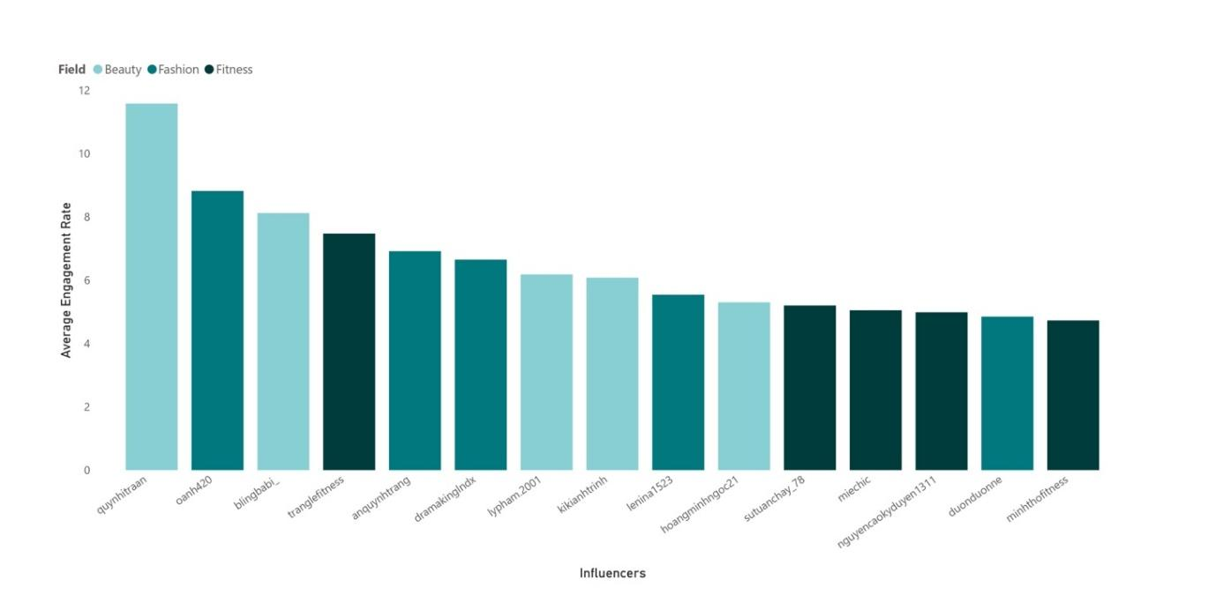

Figure 4: Average engagement rate of the top 5 across all sectors
Source: Authors' compilations
4.4. Audience sentiment and content signals
Word analysis - Word Cloud and Sentiment
The Word Cloud displays the most frequently used words in audience comments on these advertised videos, categorized by sentiment: negative, neutral, and positive. Figure 5 reveals that verbs such as “đi” (go), “nói” (talk), “thấy” (see), “làm” (do), and “biết” (know) are commonly used. Negative sentiment is represented by words like “ế_ẩm” (stagnant), “lên mụn” (breakout), “hán” (bored), and “hê” (complaint), indicating concerns about the effectiveness and potential negative impacts of the influencers. These terms reflect dissatisfaction, particularly related to products not meeting consumer expectations, resulting in poor experiences and reluctance to purchase. In contrast, the positive sentiment cloud is filled with words like “đẹp” or “xinh” (beautiful), “dễ thương” (cute), “mê” (love), and “đỉnh” (awesome), suggesting high levels of user approval and satisfaction. These positive terms indicate that the content promoted by influencers is well-received by their audience.
The neutral sentiment cloud features words like “chưa” (not), “hỏi” (ask), and “thử” (try), which convey a more neutral tone. Additionally, terms such as “mua” (buy) and “review” appear, suggesting that users are engaged in evaluating the products or services in an unbiased manner. Despite some variations in commonly used terms, there are notable similarities across posts, regardless of the influencers’ different fields. This analysis provides insights into how viewers of TikTok influencers’ videos express their sentiments and the potential effects of these sentiments on consumer attitudes and behaviors.

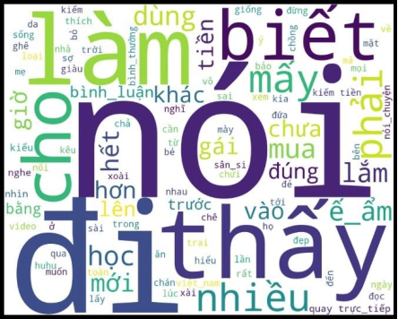
- Negative sentiment b) Neutral sentiment
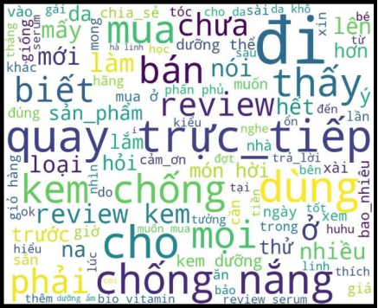

- Positive sentiment
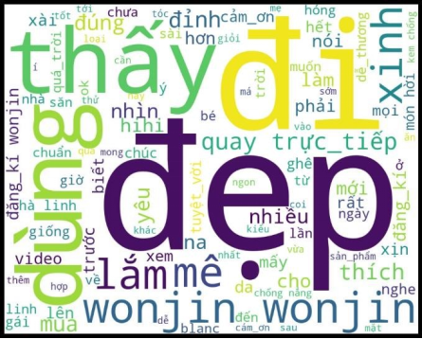

Figure 5: Word Cloud of top 100 words with sentiment
Source: Authors' compilations
Sentiment analysis of audience comments shows that positive emotional polarity is strongly associated with higher engagement, especially within Beauty and Fitness content. Neutral and negative sentiments exhibit weak or negative correlations with engagement metrics.
Word-frequency analysis indicates that positive comments emphasize attractiveness, satisfaction, and admiration, while negative comments primarily reflect dissatisfaction with product effectiveness. These patterns suggest that emotional resonance plays a central role in driving audience interaction.
Hashtag analysis demonstrates that engagement does not increase linearly with hashtag quantity. Instead, videos employing a limited number of relevant hashtags achieve higher interaction, with optimal hashtag counts varying by sector. Brand- and product-related hashtags dominate sponsored content, yet excessive tagging appears to dilute engagement.

Replies and User Comments Analysis
This study counted influencer network structures through evaluation of reply activity, as well as comment and mention interactions between influencers. Relations between nodes establish connections between influencers who interact with their audience groups. The people who choose to comment establish personal ties with social media influencers through this platform. A new connection forms automatically when a user leaves a reply to any posted comment. The setup of mentioning another person establishes a relationship between the two users. The study demonstrated that two distinct networks exist in the interaction patterns, where influencers interact directly with their commenters and commenters simultaneously interact among themselves through replies. Figure 6 presents “quynhitraan”’s network topology which demonstrates the highest engagement rate on Section 4.3, according to the illustration of influencer engagement. A direct graph containing 1,142 nodes and 1,454 edges together with 220 duplicated edges makes up this network structure. The algorithm we used to identify node relationships generated 166 separate clusters throughout the network. Edge colors have different visual representations to display the quantity of node connections. Edge colorations range from light blue for infrequent connections to deep red for instances of frequent contact.
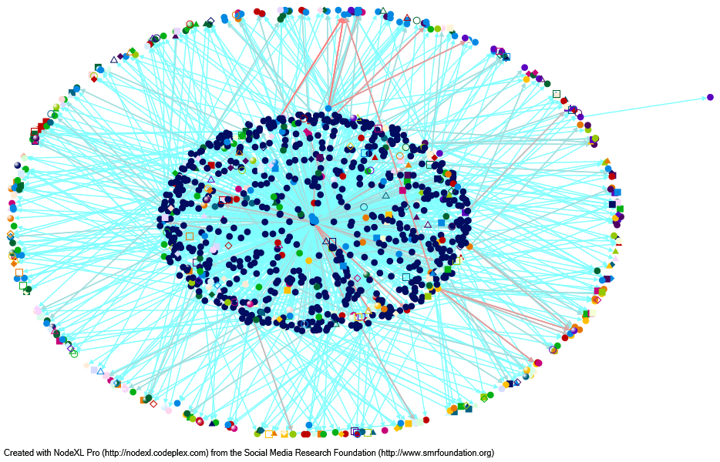
Figure 6: Network structure of the influencer “quynhitraan”
Source: Authors' compilations
The evaluation of top 15 influencers by average engagement rate revealed six influencers who failed to advertise videos although they had high audience engagement. A summary of the key graph indicators from influencers using video advertisements can be found in Table 4. Influencers maintain strong outgoing connections which indicate their audiences function at a high level of interrelationship since the node-edge distinction remains low. The social media user “quynhitraan” presented the most engagement along with the widest user network because of increased popularity. The influencer maintained connections with various groups across the network which demonstrates they have different types of audience relationships.
Overall engagement rate alone does not guarantee better performance in sponsored content, even though “dramakingIndx” maintained a close position with its moderate engagement rate. The third-ranking account “blingbabi_” achieved a high engagement rate through its reduced number of connected nodes and edges (89 nodes and 110 connections respectively). Beauty-fashion subtopics within the network share similar metrics with fitness subtopics leading to compact community structures because their networks have shorter paths between participants. The lower number of advertised videos in this field might explain these results.

Table 3: Graph metrics of the top 9 influencers with the highest average engagement rate
Source: Authors' compilations
Influencer | Field | Nodes | Edges | Duplicated |  | Groups | In-  Degree | Out-  Degree | Betweeness  Centrality | Closeness  Centrality
quynhitraan | Beauty | 1142 | 1454 |  | 220 | 166 | 77 | 862 | 153844 | 0.765
blingbabi_ | Fashion | 89 | 110 |  | 20 | 5 | 8 | 84 | 7648 | 0.957
tranglefitness | Fitness | 75 | 79 |  | 8 | 2 | 0 | 73 | 5400 | 0.987
dramakinglndx | Fashion | 922 | 1189 |  | 195 | 59 | 15 | 660 | 832929 | 0.755
lypham.2001 | Beauty | 217 | 232 |  | 11 | 20 | 2 | 144 | 45163 | 0.711
kikianhtrinh | Beauty | 590 | 679 |  | 94 | 63 | 14 | 445 | 345411 | 0.804
hoangminhngoc21 | Beauty | 548 | 623 |  | 57 | 48 | 34 | 455 | 297969 | 0.855
miechic | Fashion | 89 | 92 |  | 6 | 6 | 1 | 75 | 7572 | 0.863
nguyencaokyduyen1311 | Fitness | 207 | 212 |  | 3 | 4 | 3 | 203 | 42220 | 0.986

5. Discussion and implications
5.1. Interpretation of Core Findings: The Authenticity Gap
The empirical evidence of this research highlights the fact that there is a considerable difference between organic and sponsored content performance on TikTok in the Vietnamese market. In all industries, including Beauty, Fashion and Fitness, organic videos always had a higher engagement ratio than the advertised versions. This observation is consistent with the Parasocial Interaction (PSI) Theory, which proposes that viewers find non-commercial content more believable and relatable, thus less psychologically resistant to the message. Although advertised material can still produce significant interaction, the loss of perceived authenticity remains a critical factor as the user tends to respond to the content which is presented as an honest personal recommendation rather than a formalized commercial endorsement. This indicates that it is not just a product of reach that makes Influencer Marketing effective on TikTok, but of the influencer being perceived to have a peer-like relationship with their audience.
5.2. Metrics of Influence: Beyond the Follower Fallacy
One of the key findings of this study is the fact that the overall number of followers of an influencer is not a good indicator of engagement or video performance. The data shows that a number of influencers with the medium-sized audience were disproportionately higher in the level of interaction, especially with the total hearts metric. This trend suggests a shift toward the micro- and macro-influencer approach, when the expertise in the niche and proximity to the community are valued more than the mass-market presence. In addition, the analysis of the sector level revealed that Beauty and Fashion mega-influencers had higher engagement rates (123%) in comparison with the Fitness category, which shows that the sectoral context is a significant determinant of the upper limit of the viral potential. These dynamics lead to the assumption that the algorithm of TikTok is more concerned with the relevance of content and emotional appeal instead of the social capital that is not moving.
5.3. Strategic Content Optimization and Sentiment Dynamics
Sentiment Analysis through ViSoBERT showed a high correlation between the positive emotional polarity and high engagement rates. Interaction was mostly facilitated by positive feelings of the audience who described the product in terms of admiration and satisfaction like beautiful or awesome. Conversely, negative feelings were usually related to issues of product ineffectiveness or the lack of user satisfaction. In addition to sentiment, temporal optimization was identified as a key success factor; the highest engagement was observed at the end of the evening and the beginning of the night, which are associated with the leisure-based usage patterns in Vietnam. Also, the researchers discovered that the use of hashtags is controlled by a principle of accuracy and not quantity; videos that used few hashtags, that were topic-specific and relevant, were found to be better compared to those that over-tagged and distracted the audience engagement.
5.4. Network Topology and Community Engagement
Network Structure Analysis through Network Analytics gave more insight into the way that influencers communicate with their fan groups. Through the analysis of the activity of the replies and mention interactions, the study revealed that there are specific networks in which the influencers communicate directly with commenters, and the commenters develop peer-to-peer relationships at the same time. The network topology of the most influential influencers like quynhitraan, revealed the large user network and the existence of the high level of interrelationships, which implies that successful influencers are the central nodes in small community organizations. The implication of these results is that influencers with robust outbound ties and communication with their followers are in a better position to facilitate long-term engagement and loyalty.
5.5. Practical Implications for Brands and Creators
For marketers, especially in the FMCG (Fast-moving Consumer Goods) industry, such findings can support a story-first approach to influencer partnerships. The decline in interactions that comes with sponsored content can be addressed by implicitly integrating the brand messages into the natural storytelling formats that reflect the style of the influencer. Moreover, brands are to focus on influencers with high rates of engagement and centrality of their networks, instead of the number of followers. To content creators, the results imply that strategically time performance by maximizing performance through optimal timing with peak activity periods and emphasis on creation of high-arousal, positive emotional content is the key to maximizing performance. This means that by striking a balance between promotional and non-commercial content, the creators are able to maintain the perceived authenticity that is the core of their influential power.

References
Alonso-López, N., Sidorenko-Bautista, P., & Apablaza-Campos, A. (2023). TikTok and active audiences in processes for political and structural change: An exploratory study based on the Scottish referendum. Communication & Society, 36(1), 87–101. https://doi.org/10.15581/003.36.3.87-101
Appel, G., Grewal, L., Hadi, R., & Stephen, A. T. (2020). The future of social media in marketing. Journal of the Academy of Marketing Science, 48(1), 79–95. https://doi.org/10.1007/s11747-019-00695-1
Britt, R. K., Hayes, J. L., Britt, B. C., & Park, H. (2020). Too big to sell? A computational analysis of network and content characteristics among mega and micro beauty and fashion social media influencers. Journal of Interactive Advertising, 20(2), 111–118. https://doi.org/10.1080/15252019.2020.1763873
Chen, C., & Lu, H. (2024). Transforming a social media influencer’s influential power to followers’ word of mouth and purchase intention: The role of brand attachment, brand credibility, and parasocial relationship. Journal of Brand Management, 31(4), 415–442. https://doi.org/10.1057/s41262-023-00345-6
Chen, Y., Chen, L., & Pan, Y. (2024). Social media influencer endorsement: The conditional effects of product attribute description in sponsored influencer videos. Journal of Marketing Management, 40(5–6), 675–703. https://doi.org/10.1080/0267257X.2024.2305748
Cheng, M., Liu, J., Qi, J., & Wan, F. (2021). Differential effects of firm-generated content on consumer digital engagement and firm performance: An outside-in perspective. Industrial Marketing Management, 93, 41–58. https://doi.org/10.1016/j.indmarman.2020.12.007
Chung, S., & Cho, H. (2017). Fostering parasocial relationships with celebrities on social media: Implications for celebrity endorsement. Psychology & Marketing, 34(4), 481–495. https://doi.org/10.1002/mar.21001
Clauset, A., Newman, M. E. J., & Moore, C. (2004). Finding community structure in very large networks. Physical Review E, 70(6), 066111. https://doi.org/10.1103/PhysRevE.70.066111
Cui, G., Chung, Y., Peng, L., & Wang, Q. (2024). Clicks for money: Predicting video views through a sentiment analysis of titles and thumbnails. Journal of Business Research, 175, 114567. https://doi.org/10.1016/j.jbusres.2024.114567
Cuong, N., & Danh, N. (2021). A study of factors affecting brand awareness in the context of viral marketing in Vietnam. SSRN Electronic Journal. https://doi.org/10.2139/ssrn.3906104
Cuong, N., Thao, T., & Tien, N. (2024). Factors affecting users’ brand awareness through social media marketing on TikTok. Innovative Marketing, 20(1), 122–131. https://doi.org/10.21511/im.20(1).2024.11
Dadvari, A. (2023). Influencer marketing and consumer trust: Exploring the role of authenticity in social media endorsements. Journal of Digital Marketing Studies, 15(2), 45–60.
Dat, Q. N., Nguyen, D. Q., Nguyen, D. Q., Pham, S. B., & Nguyen, A. T. (2017). A fast and accurate Vietnamese word segmenter. Proceedings of the 8th International Workshop on Vietnamese Language and Speech Processing, 1–8.
Dat, Q. N., & Nguyen, A. T. (2020). PhoBERT: Pre-trained language models for Vietnamese. Findings of the Association for Computational Linguistics: EMNLP 2020, 1037–1042. https://doi.org/10.18653/v1/2020.findings-emnlp.92
De Veirman, M., Cauberghe, V., & Hudders, L. (2017). Marketing through Instagram influencers: The impact of number of followers and product divergence on brand attitude. International Journal of Advertising, 36(5), 798–828. https://doi.org/10.1080/02650487.2017.1348035
Elberse, A., & Verleun, J. (2012). The economic value of celebrity endorsements. Journal of Advertising Research, 52(2), 149–165. https://doi.org/10.2501/JAR-52-2-149-165
Evans, N., Wojdynski, B. W., & Hoy, M. G. (2018). How sponsorship transparency mitigates negative effects of advertising recognition. International Journal of Advertising, 38(3), 364–382. https://doi.org/10.1080/02650487.2018.1535221
Gan, J., Shi, S., Filieri, R., & Leung, W. (2023). Short video marketing and travel intentions: The interplay between visual perspective, visual content, and narration appeal. Tourism Management, 99, 104–115. https://doi.org/10.1016/j.tourman.2023.104795
Gilmore, D., et al. (2024). Building community and identity online: A content analysis of highly viewed #Autism TikTok videos. Autism in Adulthood, 6(1), 95–105. https://doi.org/10.1089/aut.2023.0001
Handranata, Y., Herlina, M., Soendoro, L., & Kamiliya, Q. (2024). Beyond the swipe: Understanding the power of TikTok marketing—Interaction, entertainment, and trendiness in shaping purchase intentions. International Journal of Data and Network Science, 8(4), 2519–2526. https://doi.org/10.5267/j.ijdns.2024.5.002
Harel, D., & Koren, Y. (2001). A fast multi-scale method for drawing large graphs. Proceedings of the 8th International Symposium on Graph Drawing, 183–196.
Hovland, C. I., Janis, I. L., & Kelley, H. H. (1953). Communication and persuasion: Psychological studies of opinion change. Yale University Press.
Indrawati, P. C., Calista, P. Y., & Muthaiyah, S. (2023). eWOM via the TikTok application and its influence on the purchase intention of Somethinc products. Asia Pacific Management Review, 28(2), 174–184. https://doi.org/10.1016/j.apmrv.2023.02.001
Kay, S., Mulcahy, R., & Parkinson, J. (2022). When less is more: The impact of influencer marketing disclosure on consumer engagement. Journal of Interactive Marketing, 59, 45–60.
Li, P., & Sun, Y. (2024). Impact of internet celebrities’ short videos on audiences’ visit intentions: Is beauty power? Humanities and Social Sciences Communications, 11(1), 1–12. https://doi.org/10.1057/s41599-024-02721-2
Liu, X., & Zheng, X. (2024). The persuasive power of social media influencers in brand credibility and purchase intention. Humanities and Social Sciences Communications, 11(1), 1–12. https://doi.org/10.1057/s41599-024-02652-y
Marti-Ochoa, J., Rodríguez, L., & Pérez, M. (2024). Data extraction from social media platforms for marketing analytics research. Journal of Data Science Applications, 12(1), 33–49.
Mehta, P., & Pandya, S. (2020). Sentiment analysis techniques for social media data: A review. International Journal of Computer Applications, 176(36), 1–7.
Nurjannah, S., & Surianto, M. (2022). TikTok influencer marketing and its impact on consumer purchase intention. Journal of Digital Business and Marketing, 4(2), 85–97.
Schellewald, A. (2021). Communicative forms on TikTok: Perspectives from digital ethnography. International Journal of Communication, 15, 1437–1457.
Tartaraj, A., Hoxha, V., & Kelmendi, B. (2024). Social media influencers and consumer engagement in emerging markets. Marketing and Management of Innovations, 2, 118–130.
Tzoumaka, E., Tsiotsou, R. H., & Siomkos, G. (2016). Delineating the role of influencer credibility in social media advertising effectiveness. Journal of Marketing Communications, 22(3), 1–17.
Van Driel, L., & Dumitrica, D. (2021). Selling brands while staying authentic: The professionalization of Instagram influencers. Convergence, 27(1), 66–84. https://doi.org/10.1177/1354856520902136
Walternath, L., Schramm-Klein, H., & Wagner, G. (2022). Influencer marketing effectiveness: The role of credibility and authenticity in social media endorsements. Journal of Marketing Analytics, 10(3), 187–199.
Wu, Y., Chen, L., & Huang, Z. (2023). Social media data mining for influencer marketing research: Methods and challenges. Information Processing & Management, 60(5), 103345.
Yew, J., Kamarulzaman, Y., & Yusof, J. (2018). Understanding social media engagement: The impact of influencer content on consumer interaction. Journal of Interactive Advertising, 18(2), 122–134.

Tác giả liên hệ, Email: k63.2412255005@ftu.edu.vn
ViSoBERT a language model designed explicitly for Vietnamese social media texts

