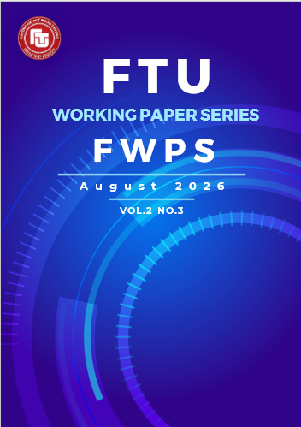
Working Paper 2026.2.3.4
- Vol.2 , No.3

TÁC ĐỘNG CỦA CHẤT LƯỢNG DỊCH VỤ LOGISTICS VÀ SỰ TÍCH HỢP KÊNH ĐẾN Ý ĐỊNH TIẾP TỤC MUA SẮM SẢN PHẨM CHĂM SÓC DA ĐA KÊNH CỦA GEN Z TẠI TP. HỒ CHÍ MINH
Nguyễn Trần Cẩm Anh, Lê Ngọc Nguyên Hân, Hoàng Quế Đan, Đặng Hà Bảo Trang, Lê Thị Trà My
Sinh viên K62 Tiêu chuẩn Kinh tế đối ngoại – Khoa Kinh doanh & Thương mại quốc tế
Phân hiệu trường Đại học Ngoại thương, Thành phố Hồ Chí Minh, Việt Nam

Nguyễn Thị Quỳnh Nga
Giảng viên Phân hiệu
Phân hiệu trường Đại học Ngoại thương, Thành phố Hồ Chí Minh, Việt Nam
Tóm tắt
Sự hình thành sự hài lòng của khách hàng trong bán lẻ chăm sóc da đa kênh vẫn chưa được hiểu đầy đủ, đặc biệt trong nhóm người tiêu dùng Gen Z, những người quen thuộc với công nghệ số và kỳ vọng trải nghiệm liền mạch giữa các kênh mua sắm. Đặc biệt, vai trò của sự tích hợp ở cấp độ hệ thống và trải nghiệm ở cấp độ giao dịch vẫn chưa được làm rõ. Dựa trên dữ liệu khảo sát từ 253 người tiêu dùng Gen Z và phương pháp mô hình phương trình cấu trúc bình phương tối thiểu từng phần (PLS-SEM), nghiên cứu này xem xét cách cảm nhận về chất lượng dịch vụ logistics và chất lượng tích hợp kênh ảnh hưởng đến sự hài lòng của khách hàng và ý định tiếp tục sử dụng. Kết quả cho thấy cả hai yếu tố này đều góp phần nâng cao sự hài lòng của khách hàng và mức độ sẵn sàng tiếp nhận các chương trình quan hệ khách hàng, từ đó thúc đẩy ý định tiếp tục sử dụng. Trong đó, chất lượng tích hợp kênh có tác động mạnh hơn đến sự hài lòng theo từng giao dịch so với chất lượng dịch vụ logistics. Đáng chú ý, sự hài lòng theo từng giao dịch không ảnh hưởng đáng kể đến sự hài lòng tích lũy, cho thấy người tiêu dùng Gen Z có xu hướng đánh giá trải nghiệm đa kênh một cách tổng thể thay vì dựa trên các giao dịch riêng lẻ. Những kết quả này cung cấp bằng chứng thực nghiệm, góp phần làm rõ cơ chế duy trì khách hàng trong ngành bán lẻ chăm sóc da đa kênh.
Từ khoá: bán lẻ đa kênh, chất lượng tích hợp kênh, chất lượng dịch vụ logistics, sự hài lòng khách hàng, ý định tiếp tục mua sắm, mức độ sẵn sàng tiếp nhận chương trình quan hệ khách hàng

THE IMPACT OF LOGISTICS SERVICE QUALITY AND CHANNEL INTEGRATION ON GEN Z’S INTENTION TO CONTINUE PURCHASING OMNICHANNEL SKINCARE PRODUCTS IN HO CHI MINH CITY
Abstract
Customer satisfaction formation in omni-channel skincare retailing remains insufficiently understood, particularly among Generation Z consumers, who are highly familiar with digital technologies and expect seamless experiences across multiple channels. In particular, the roles of system-level integration and transaction-level experiences remain unclear. Using survey data from 253 Gen Z consumers and partial least squares structural equation modeling, this study examines how perceived logistics service quality and perceived channel integration quality shape customer satisfaction and continuance intention. The findings indicate that both logistics service quality and channel integration quality play critical roles in enhancing customer satisfaction and relationship program receptiveness, which subsequently foster continuance intention. Channel integration quality demonstrates a stronger influence on transaction-specific satisfaction than logistics service quality. Notably, transaction-specific satisfaction does not significantly contribute to cumulative satisfaction, suggesting that Gen Z consumers tend to evaluate omni-channel experiences holistically rather than through isolated transactions. These results provide empirical insights into customer retention mechanisms in the omni-channel skincare industry.
Keywords: omnichannel retailing, channel integration quality, logistics service quality, customer satisfaction, continuance intention, relationship program receptiveness
1. Introduction
Along with the growth of e-commerce, omni-channel selling has emerged as the most effective approach to boost revenue. Sapo’s survey recorded that 55.7% of sellers with revenue growth adopt this model (Sapo, 2024). Besides, traditional wholesalers are increasingly expanding to provide products through diverse channels such as physical stores, e-commerce platforms, social media and so on (Nguyen et al., 2025). This phenomenon indicated a crucial role of a omni-channel strategy in reaching different customer segments and maximizing profits.
Currently, the skincare market in Vietnam is experiencing strong growth with a diverse range of customer segments. According to Statista (2025), the total revenue from skincare products in Vietnam is estimated to reach 0.9 billion USD in 2025. Therefore, in order to enhance customer experience and strengthen competitive advantage, skincare brands are increasingly integrating logistics service quality and channel integration quality into their product distribution operations.
A significant number of studies have been recorded on the relationship between perceived logistics service quality, perceived channel integration quality, and repurchase intention, including those by Prassida & Hsu (2023) and Prassida et al. (2024). These articles, conducted in Indonesia, investigate the mechanisms by which channel and logistics service integration impacts customer satisfaction and repurchase intention. Furthermore, relationship program receptiveness factor impacts customer loyalty (Gao et al., 2021) and lifetime value (Natarajan et al., 2023). On the other hand, the influence of perceived logistics service quality and perceived channel integration quality on continuance intention has only been examined, while customer behavior has a broader scope (Huang et al., 2023).
However, several research gaps still remain. First, there has been no previous study examining the impact of perceived logistics service quality on relationship program receptiveness and the impact of relationship program receptiveness on customer intentions in the skincare industry in Vietnam. Second, most existing studies have primarily focused on the relationships between perceived channel integration quality, perceived logistics service quality, satisfaction, and purchase intention, while overlooking continuance intention when using these services.
Therefore, this study aims to examine the relationship between perceived logistics service quality and relationship program receptiveness, the relationship between relationship program receptiveness and continuance intention. In addition, this study investigates the effects of perceived logistics service quality, perceived channel integration quality, transaction-specific satisfaction, and cumulative satisfaction on continuance intention. Furthermore, the study provides managerial implications for skincare businesses in Ho Chi Minh City to develop strategies that foster customer commitment to service usage.
2. Theoretical framework
2.1. Omni-channel
There are various definitions of omnichannel and its impacts in the literature. According to Cocco et al. (2022), omnichannel refers to the strategic integration of multiple channels and touchpoints to create a seamless customer experience. This process is designed to ensure continuity and consistency as customers shop and move across different channels of the business. The continuity of omnichannel provides customers with a seamless and more convenient shopping experience (Rahman et al., 2022; Cocco et al., 2022). Meanwhile, consistency benefits customers by synchronizing their information across channels and limiting the need to recheck information on one channel while shopping on another (Sharma et al., 2024).
Meanwhile, having been born and raised during a period of rapid technological advancement, Generation Z expects a fast and convenient shopping experience (Elgeka et al., 2024). Approximately 67% of Gen Z respondents in a survey conducted (Chang et al., 2021) showed expectations for seamless experiences when moving across multiple channels, prioritizing advanced technological features while still ensuring the security of personal information and payment data (Rahman et al., 2026). In particular, the use of skincare products among Gen Z begins at a relatively early age, with about 45.4% of Gen Z females having started using such products before the age of 19 (Chandra et al., 2024). Therefore, purchasing skincare products through e-commerce platforms and omnichannel retail systems has become increasingly common among Gen Z consumers (Elgeka et al., 2024).

2.2. Stimulus - Organism - Response framework
The Stimulus - Organism - Response (SOR) framework was developed by Mehrabian & Russell (1974). The first stage is the stimulus stage, which refers to the stimuli from the external environment. In the omnichannel retailing context, stimuli are associated with activities that are integrated across all channels to deliver a seamless shopping experience (Mishra et al., 2021). Next, the second stage is the organism stage, in which environmental stimuli are manifested through internal emotional or cognitive states. Organism-related factors may include customer empowerment (Zhang et al., 2018), perceived values (Amit et al., 2021), commitment, and relationship program receptiveness (Natarajan & Raghavan, 2023). Finally, the response stage refers to individuals’ behavioral reactions, which may include reuse intention (Lin et al., 2023), omnichannel usage intention (Gao et al., 2021), continuance intention, and green engagement intention (Ding & Lee, 2024).
The study by Prassida & Hsu (2022) examined the effects of perceived channel integration and perceived logistics quality on repurchase intention, as well as the mediating roles of transaction-specific satisfaction and cumulative satisfaction, using the SOR framework. In their study, perceived channel integration and perceived logistics quality were stimulus factors; transaction-specific satisfaction and cumulative satisfaction were considered organism factors; and repurchase intention was response.
In this study, the stimulus stage includes perceived channel integration and perceived logistics quality; the organism stage consists of transaction-specific satisfaction, cumulative satisfaction, and relationship program receptiveness; and the response stage is extended to include continuance intention.
By integrating relationship program receptiveness into the SOR framework in an omnichannel context, this study extends prior research and provides additional theoretical insight into how operational and relational factors jointly influence customers’ continuance intention. Furthermore, prior studies on the SOR framework in omnichannel retailing have mainly focused on general retail contexts or consumers in developed markets, this study contributes to the existing literature by examining the proposed framework in the context of skincare products among Gen Z consumers in Vietnam.

3. Hypothesis development

3.1. Perceived logistics service quality and perceived channel integration quality
Channel integration refers to the extent to which a firm aligns and coordinates its various interaction channels, including online platforms, physical retail outlets, and other available touchpoints (Hamouda, 2019). The quality of channel integration indicates the degree to which customers can consistently access product information, service details, and promotional offers, complete transactions, and receive orders seamlessly across multiple channels (Prassida & Hsu, 2022). Moreover, previous research on channel integration quality has applied various conceptualizations and dimensionalisations of this construct across different contexts (Sousa & Voss, 2006; Lee et al., 2018; Hossain et al., 2020; Prassida & Hsu, 2022). Focusing on consumer perceptions in omnichannel retailing, researchers adopted the channel integration dimensions proposed in prior studies by Prassida & Hsu (2022), including (1) perceived channel breadth, (2) perceived channel transparency, (3) perceived channel appropriateness, (4) perceived information consistency, (5) perceived transaction data integration, (6) perceived system consistency, (7) perceived image consistency, (8) perceived privacy, (9) perceived security, and (10) perceived service recovery accessibility.
Perceived logistics service quality refers to consumers’ overall evaluation of logistics performance associated with product delivery, which is reflected through their perceptions of product availability, delivery timeliness, and product condition (Rabinovich & Bailey, 2004; Xing et al., 2010). Early research conceptualized logistics service quality as a segment-customized process aligned with retailers’ order fulfillment activities (Mentzer et al., 2001). Subsequent studies, however, emphasized the distinction between internal logistics processes and external customers’ perceptions of logistics service outcomes (Bienstock et al., 2008). Accordingly, this study defines perceived logistics service quality by emphasizing outcome-oriented logistics performance dimensions derived from Mentzer et al., (2001) and Bienstock et al. (2008), given their direct relevance to customer satisfaction in omnichannel contexts, including (1) Perceived order quality, (2) Perceived order accuracy, (3) Perceived order condition, (4) Perceived timeliness, (5) Perceived availability.
Within the omnichannel landscape, consumers anticipate a frictionless experience characterized by total flexibility in ordering and fulfillment across diverse touchpoints. Effective retail strategies must, therefore, synthesize channel-specific activities with logistics management to facilitate a cohesive customer journey (Hübner et al., 2016; Murfield et al., 2017). As the delivery of uniform, synchronized services hinges on logistical efficiency (Yumurtacı Hüseyinoğlu et al., 2018; Ishfaq et al., 2016), and success is ultimately defined by the customer's viewpoint (Sorkun et al., 2020), enhancing perceived logistics service quality is essential for realizing a high level of perceived channel integration quality. Consequently, the following hypothesis is proposed.
H1: Perceived logistics service quality positively influences channel integration quality.

3.2. Perceived channel integration quality and customer satisfaction
Transaction-specific satisfaction can be defined as customers’ evaluation of a specific service encounter at a single point in time (Zhao et al., 2012). It captures customers’ psychological reactions to particular events in a service transaction on a given occasion or in a given time period (Jones & Suh, 2000; Olsen & Johnson, 2003). Transaction-specific satisfaction involves the customer’s satisfaction or dissatisfaction with a discrete service encounter (Bitner & Hubbert, 1994). Cumulative satisfaction refers to the overall evaluation of satisfaction that develops across a series of purchase experiences, arising from the combined effects of transaction-specific satisfaction at different points of service interaction (S. Yang et al, 2017). Accordingly, Zhao et al. (2012) argue that cumulative satisfaction is influenced by various factors present across multiple service encounters.
Channel integration quality, functioning as a critical environmental stimulus, is posited to shape consumers’ internal states, particularly their level of satisfaction (Becker & Jaakkola, 2020; Le & Nguyen-Le, 2021). Existing literature underscores a positive correlation between the perceived sophistication of channel integration and heightened customer contentment (Seck & Philippe, 2013). Within the omnichannel framework, where integration quality may fluctuate across various transactional touchpoints, perceived integration quality serves as a primary determinant of satisfaction at both the micro and macro levels. While frictionless cross-channel interactions facilitate transaction-specific satisfaction during isolated encounters, a consistently favorable perception over time fosters cumulative satisfaction. Accordingly, the following hypotheses are proposed.
H2. Perceived channel integration quality positively influences transaction-specific satisfaction.
H3. Perceived channel integration quality positively influences cumulative satisfaction.

3.3. Perceived channel integration quality and relationship program receptiveness
Relationship program receptiveness refers to the precise kind of relational behavior in which a customer wants to establish a relationship with a firm, as well as the benefits associated with the customer's desire to engage (Ashley et al., 2011; Gao & Huang, 2021). Ashley et al. (2011) then concluded that relationship programs are marked by five behaviors, such as joining a firm’s postal mailing list, joining a firm’s e-mail list, applying for loyalty cards, signing up for a firm’s credit card, and mailing in rebate offers. Therefore, the relationship program receptiveness is considered to be a behavior-oriented construct.
In an omnichannel context, how a customer views the quality of channel integration plays a huge role in their willingness to join these programs. According to Gao & Huang (2021), high-quality channel integration acts as a functional driver that reduces customer uncertainty and perceived risk, making them more open to a firm’s relational tactics. When a retailer connects its online and offline channels smoothly, it enhances the perceived fluency of the customer journey, which fosters a sense of trust and commitment (Shen et al., 2018). This trust is essential, as customers could become more comfortable sharing personal data across platforms when they perceive the system as reliable and secure (Hossain et al., 2020). A well-integrated system also ensures that rewards and benefits are accessible everywhere, making programs like store-specific credit cards or rebate offers more attractive. Thus, the following hypothesis is presented:
H4: Perceived channel integration quality positively influences relationship program receptiveness

3.4. Perceived logistics service quality and customer satisfaction
In omnichannel retailing, logistics service quality is considered essential to achieve customer satisfaction (Mentzer et al., 2001). Previous studies highlight the positive effect of logistics service quality on customer satisfaction (Murfield et al., 2017; Le et al., 2020; Prassida et al., 2024). Accordingly, when customers perceive high logistics service quality during a specific transaction, such as on-time delivery and order fulfillment within a single transaction, these positive logistics experiences are likely to enhance their transaction-specific satisfaction. Over time, consistent logistics service quality across multiple transactions reinforces these positive evaluations, integrating into customers’ overall assessment of the retailer and significantly leading to cumulative satisfaction. Thus, the following hypotheses are proposed.
H5: Perceived logistics service quality positively influences transaction-specific satisfaction
H6: Perceived logistics service quality positively influences cumulative satisfaction

3.5. Perceived logistics service quality and relationship program receptiveness
Previous research suggests that convenience concerns may hinder customer engagement in firms’ relationship marketing programs (Noble & Phillips, 2004). High logistics service quality, characterized by reliable delivery, accurate order fulfillment, and convenient return processes, reduces customer effort and inconvenience during service encounters. As a result, customers are more likely to perceive relational interactions as valuable rather than burdensome. Furthermore, customers who perceive higher value and develop a stronger interest in a firm tend to be more receptive to receiving communications and participating in relationship marketing programs (Ashley et al., 2010). Therefore, it is proposed that:
H7: Perceived logistics service quality positively influences relationship program receptiveness

3.6. Customer satisfaction and continuance intention
Continuance intention refers to a user’s satisfaction with prior usage experiences and their perceived usefulness of continued use (Bhattacherjee, 2001). This study defines continuance intention as the customers’ commitment to continue using a skincare brand’s integration channel services, reflecting users’ satisfaction and their willingness to sustain engagement across multiple, integrated touch points over time.
Prior research suggests that consumers typically make purchase or repurchase decisions by evaluating whether their overall experiences with a product or service have been satisfying and enjoyable (Majeed et al, 2022). Olsen and Johnson (2003) demonstrated that transaction-specific satisfaction and cumulative satisfaction influenced customers’ behavioral intentions in distinct ways. Specifically, transaction-specific satisfaction is more effective in capturing fluctuations in performance and the immediate responses of consumers, whereas cumulative satisfaction more accurately represents the long-term relationship between buyers and retailers (Zhao et al., 2012). Furthermore, Zhao et al. (2012) demonstrated that both transaction-specific satisfaction and cumulative satisfaction have significant and positive effects on continuance intention. In addition, previous studies have demonstrated that transaction-specific satisfaction has a positive impact on cumulative satisfaction in the omni-channel context (Jones & Suh, 2000; S.Yang et al., 2017). Based on the above discussion, the following hypotheses are formulated:
H8: Transaction-specific satisfaction positively influences cumulative satisfaction.
H9: Transaction-specific satisfaction positively influences continuance intention.
H10: Cumulative satisfaction positively influences continuance intention.

3.7. Relationship program receptiveness and continuance intention
Relationship program receptiveness is applied when customers are ready to engage in actions that establish and develop a formal relationship with the brand (Natarajan et al., 2023), thereby enabling firms to collect personal information and build strong, long-term relationships with customers. Relationship program receptiveness is also positively associated with customer lifetime value, suggesting that the implementation of promotional and customer relationship programs enhances customer satisfaction and strengthens consumer loyalty. Previous studies have also indicated that loyalty reflects a commitment (Amin et al, 2023) whereby consumers perceive continued use of a brand’s services, rather than switching to competitors, as a safer and less risky option.
Moreover, consumers tend to develop habitual purchasing behavior at familiar stores, reducing the need for extensive consideration and complex decision-making (Hepola et al., 2020; Zhang et al., 2010). Overall, as relationship program receptiveness increases, customers are more inclined to maintain long-term relationships, and the benefits obtained from participating in these programs motivate them to return and shop more frequently. Therefore:
H11: Relationship Program Receptiveness positively influences Continuance Intention
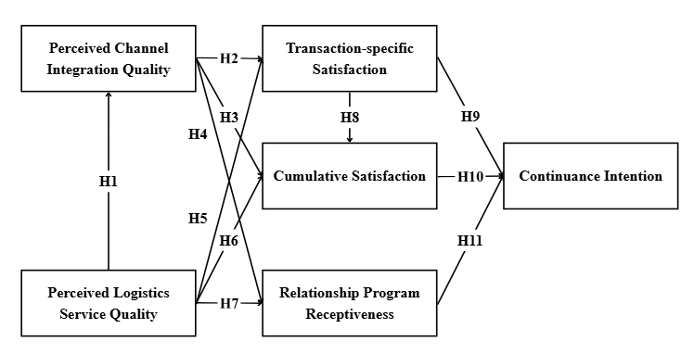
Figure 1. Proposed research model
Source: The authors

4. Methodology

4.1. Measurement scale and questionnaire design
The questionnaire was structured into three sections. Section 1 consisted of four screening questions. Section 2, which constituted the main part of the questionnaire, included 64 items measured using a five-point Likert scale ranging from (1) Strongly disagree to (5) Strongly agree. Section 3 contained questions related to the demographic characteristics of the respondents.
The questionnaire was developed based on a synthesis of prior studies addressing related research themes. The measurement scale for perceived channel integration quality was adapted from Prassida and Hsu (2022) and operationalized as a second-order reflective construct consisting of ten first-order dimensions. For the perceived channel appropriateness dimension, although the original scale included only two items, this study added a third item to meet the minimum indicator requirement for latent constructs as recommended by Hair et al. (2010). The additional item was developed based on Task-Technology Fit theory (Goodhue & Thompson, 1995) and Media Richness Theory (King & Xia, 1997) to capture the logical allocation of service functions across channels. Perceived logistics service quality was measured as a second-order reflective construct with five first-order dimensions, drawing on Prassida & Hsu (2022). Transaction-specific satisfaction and cumulative satisfaction were also adapted from Prassida and Hsu (2022). Relationship program receptiveness was measured using five items from Natarajan & Ramanan (2024), Continuance intention was measured using five items from Zhao et al. (2012).

4.2. Data collection and analysis
The study targeted consumers who had experience purchasing skincare products through omnichannel platforms in Ho Chi Minh City. Using a convenience non-probability sampling approach, the survey was conducted over eight days from January 17 to January 24, 2026. All data were collected via an online questionnaire administered through Google Forms.
A total of 347 responses were collected, of which 253 valid samples remained after data screening and cleaning. This sample size satisfies the minimum requirement for PLS-SEM analysis recommended by Hair et al. (2010), which suggests a minimum sample size equal to ten times the number of direct relationships in the structural model. The study employed partial least squares structural equation modeling (PLS-SEM) to analyze the data using SmartPLS 3.

5. Results

5.1. Descriptive data analysis
According to the survey results, the gender ratio in the sample is unbalanced, comprising 50 male respondents (equivalent to 19.76%) and 201 female respondents (79.45%). Regarding age, the majority of respondents are aged 18-29, accounting for 245 samples (96.8%); the remaining age groups account for a small proportion, including 14-17 years old with 8 samples (3.2%). The average monthly expenditure is largely under 5 million VND, represented by 154 respondents (60.9%). Regarding occupation, the sample spans various sectors, but students account for the largest proportion at 92.9%. Finally, the cosmetic purchasing channel most frequently used by respondents is e-commerce platforms, with 157 samples (62.5%).

5.2. Measurement model analysis
Hair et al. (2017) propose that the assessment of scale reliability should focus on two indicators: Cronbach's Alpha and Composite Reliability. The closer Cronbach's Alpha is to 1, the higher the reliability. Appropriate Composite Reliability values range from 0.7 to 0.9 (Nunnally and Bernstein, 1994). If this value exceeds 0.95, it is necessary to check for potential indicator redundancy.
After testing the reliability of the scales, the results show that the Cronbach's Alpha values for all factors are greater than 0.7 (ranging from 0.862 to 0.94). Most Composite Reliability values fall within the 0.8-0.9 range; no factor has a Composite Reliability value greater than 0.95, ensuring there is no indicator redundancy. Therefore, it can be concluded that the initial scales ensure reliability and good measurement, and all observed variables are retained in the scale.
Furthermore, the AVE values for all scales are 0.773 or higher, exceeding the 0.5 threshold, which indicates that the scales meet the requirements for convergent validity (Hulland, 1999).
Table 1. Results of reliability and convergent validity testing
Source: Survey data analysis results
Construct and  Dimension |  | Cronbach's Alpha | rho_A | Composite Reliability | Average Variance Extracted (AVE)
PCIQ | PCB | 0.904 | 0.904 | 0.94 | 0.839
PCIQ | IMC | 0.886 | 0.889 | 0.929 | 0.814
PCIQ | PCA | 0.874 | 0.877 | 0.923 | 0.799
PCIQ | PCT | 0.898 | 0.899 | 0.937 | 0.831
PCIQ | PIC | 0.902 | 0.902 | 0.932 | 0.773
PCIQ | PRI | 0.872 | 0.873 | 0.922 | 0.797
PCIQ | PSC | 0.896 | 0.897 | 0.935 | 0.828
PCIQ | SEC | 0.907 | 0.908 | 0.935 | 0.782
PCIQ | SRA | 0.897 | 0.899 | 0.936 | 0.83
PCIQ | TDI | 0.913 | 0.913 | 0.939 | 0.794
PLSQ | OQU | 0.884 | 0.885 | 0.928 | 0.812
PLSQ | OCO | 0.889 | 0.889 | 0.931 | 0.818
PLSQ | OAC | 0.884 | 0.885 | 0.929 | 0.812
PLSQ | TIM | 0.887 | 0.888 | 0.93 | 0.816
PLSQ | AVA | 0.881 | 0.881 | 0.927 | 0.808
RPR |  | 0.932 | 0.933 | 0.949 | 0.787
TRS |  | 0.868 | 0.87 | 0.919 | 0.791
CUS |  | 0.862 | 0.865 | 0.916 | 0.783
COI |  | 0.94 | 0.941 | 0.954 | 0.806
Note: PLSQ = Perceived Logistics Service Quality, PCIQ = Perceived Channel Integration Quality, AVA = Perceived Availability, COI = Continuance Intention, CUS = Cumulative Satisfaction, IMC = Perceived Image Consistency, OAC = Perceived Order Accuracy, OCO = Perceived Order Condition, OQU = Perceived Order Quality, PCA = Perceived Channel Appropriateness, PCB = Perceived Channel Breadth, PCT = Perceived Channel Transparency, PIC = Perceived Information Consistency, PRI = Perceived Privacy, PSC = Perceived System Consistency, RPR = Relationship Program Receptiveness, SEC = Perceived Security, SRA = Perceived Service Recovery Accessibility, TDI = Perceived Transaction Data Integration, TIM = Perceived Timeliness, TRS = Transaction-Specific Satisfaction
According to Fornell & Larcker (1981), discriminant validity is established when the square root of the Average Variance Extracted (AVE) for each latent variable exceeds its correlations with other latent variables in the model. Henseler et al. (2015) propose assessing scale discriminant validity using the Heterotrait-Monotrait Ratio (HTMT). Discriminant validity is considered well-established if the HTMT value is below 0.85.
Consequently, the results from Table 2 indicate that all HTMT values range from 0.06 to 0.841, falling below the 0.85 threshold. This confirms that the discriminant validity of the scales is ensured according to the HTMT criterion (Henseler et al., 2015). Additionally, the results from Table 3 demonstrate that the scales satisfy discriminant validity based on the Fornell and Larcker (1981) method, as the square roots of the AVEs for all constructs are greater than the highest correlation coefficients between the corresponding construct pairs. Based on these test results, it can be concluded that the research variables possess discriminant validity and are eligible for subsequent analyses.
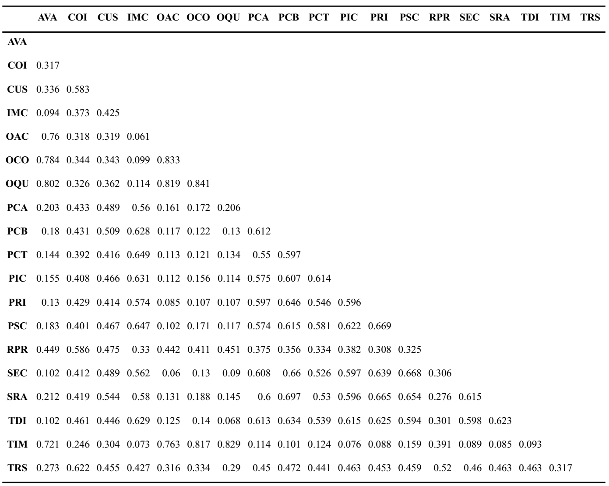
Figure 2. Discriminant validity based on HTMT criterion
Source: Survey data analysis results
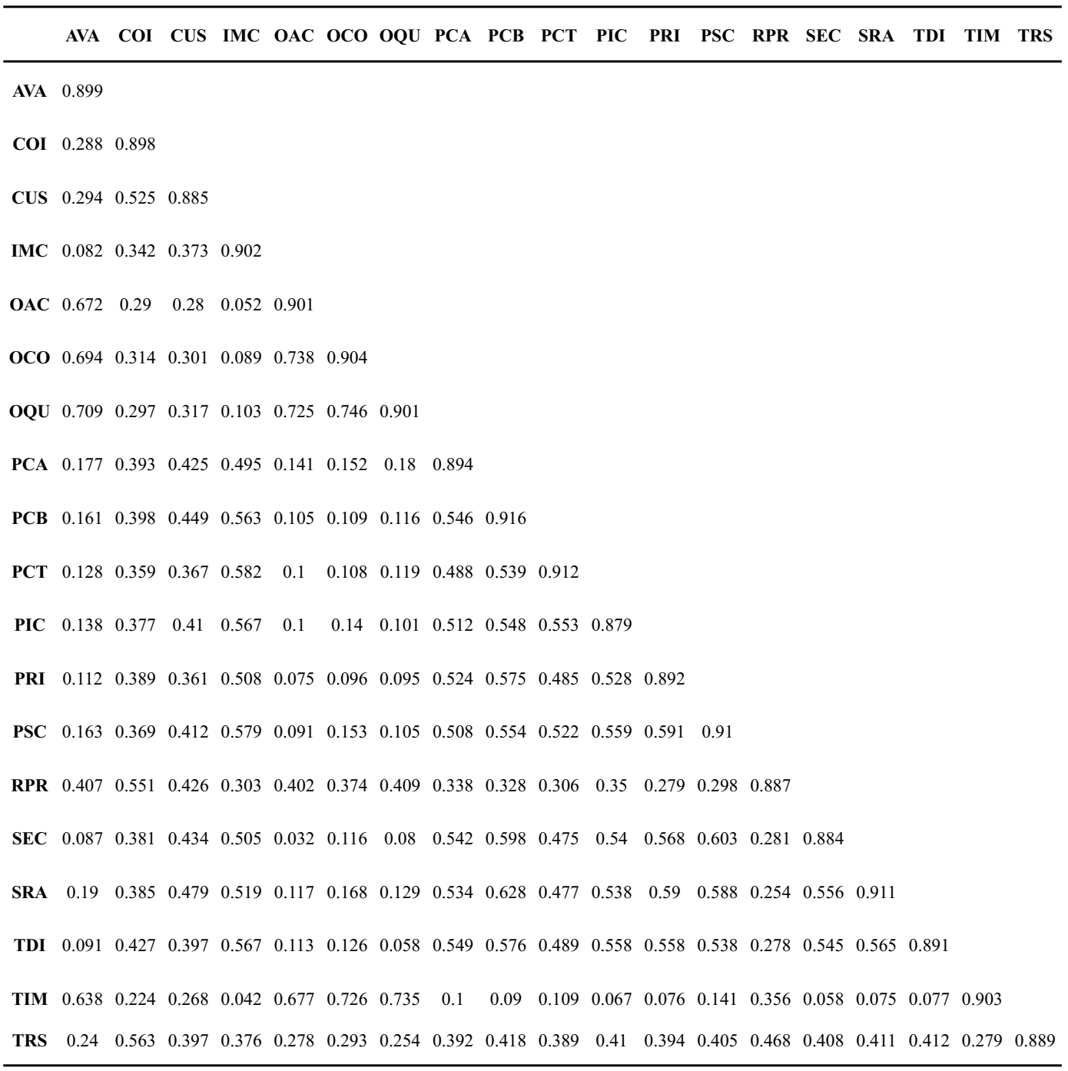
Figure 3. Discriminant validity based on Fornell-Larcker criterion
Source: Survey data analysis results

5.3. Structural model and hypothesis testing
Table 2. Results of testing multicollinearity in the model and effect size (f²)
Source: Survey data analysis results
Relationships | VIF | f²
H1: PLSQ → PCIQ | 1 | 0.026
H2. PCIQ → TRS | 1.026 | 0.342
H3. PCIQ → CUS | 1.377 | 0.229
H4: PCIQ → RPR | 1.026 | 0.151
H5: PLSQ → TRS | 1.026 | 0.076
H6: PLSQ → CUS | 1.105 | 0.078
H7: PLSQ → RPR | 1.026 | 0.216
H8: TRS → CUS | 1.482 | 0.008
H9: TRS → COI | 1.364 | 0.145
H10: CUS → COI | 1.301 | 0.115
H11: RPR → COI | 1.403 | 0.11
Note: PLSQ = Perceived Logistics Service Quality, PCIQ = Perceived Channel Integration Quality, TRS = Transaction-specific satisfaction, CUS = Cumulative satisfaction, RPR = Relationship Program Receptiveness , COI = Continuance Intention
Table 3. Coefficient of determination (R²) and predictive relevance (Q²)
Source: Survey data analysis results
 | R² | Q²
PCIQ | 0.026 | 0.012
TRS | 0.325 | 0.254
CUS | 0.355 | 0.272
RPR | 0.304 | 0.237
COI | 0.482 | 0.383
VIF values are below 3, ranging from 1 to 1.482. Therefore, it can be concluded that multicollinearity is unlikely to occur in the model. (Hair et al., 2019). In addition, f² values are generally greater than 0.02, ranging from 0.026 to 0.342. Thus, the independent variables exert effects on the dependent variables at a slight to moderate level (Cohen, 2013). An exception is the relationship between transaction-specific satisfaction and cumulative satisfaction (f² = 0.008), which is a negligible effect.
Furthermore, R² values of most mediating and dependent variables exceed 0.25, with the exception of perceived channel integration quality (R² = 0.026), suggesting a moderate explanatory power of the related models (Henseler et al., 2009). The Q² values mainly range from 0.237 to 0.383, indicating predictive relevance at a slight to moderate level (Hair et al., 2019), except for perceived channel integration quality (Q² = 0.012).
Table 4. Hypothesis testing results
Source: Survey data analysis results
Relationships | Original  Sample (O) | Sample  Mean (M) | Standard deviation (STDEV) | T statistics | P values | Results
H1: PLSQ → PCIQ | 0.16 | 0.161 | 0.065 | 2.475 | 0.013 | Supported
H2. PCIQ → TRS | 0.486 | 0.487 | 0.046 | 10.553 | 0 | Supported
H3. PCIQ → CUS | 0.451 | 0.451 | 0.058 | 7.788 | 0 | Supported
H4: PCIQ → RPR | 0.329 | 0.329 | 0.056 | 5.878 | 0 | Supported
H5: PLSQ → TRS | 0.23 | 0.231 | 0.051 | 4.509 | 0 | Supported
H6: PLSQ → CUS | 0.235 | 0.236 | 0.051 | 4.651 | 0 | Supported
H7: PLSQ → RPR | 0.393 | 0.394 | 0.055 | 7.195 | 0 | Supported
H8: TRS → CUS | 0.089 | 0.089 | 0.061 | 1.441 | 0.15 | Rejected
H9: TRS → COI | 0.321 | 0.321 | 0.052 | 6.124 | 0 | Supported
H10: CUS → COI | 0.278 | 0.278 | 0.05 | 5.57 | 0 | Supported
H11: RPR → COI | 0.282 | 0.283 | 0.054 | 5.183 | 0 | Supported
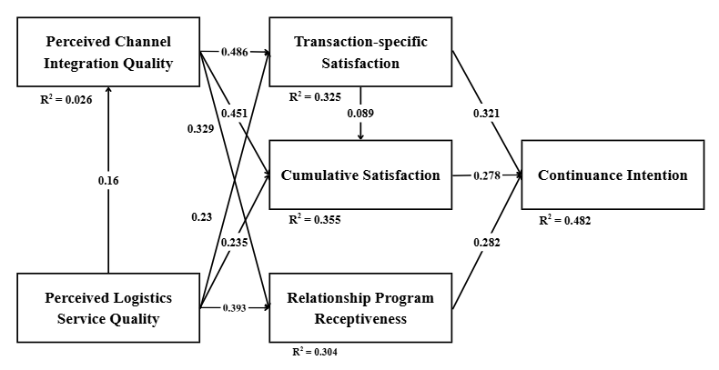
Figure 4. Results of hypothesis testing using the bootstrapping technique with 5,000 resamples
Source: The authors
To test the hypotheses, the study employed the bootstrapping technique with 5,000 resamples. The results reveal that perceived logistics service quality has a positive effect on perceived channel integration, with a path coefficient of 0.16 and a significance level p_value < 0.05. Therefore, H1 is supported.
Moreover, perceived channel integration quality positively influences transaction-specific satisfaction, cumulative satisfaction and relationship program receptiveness. Accordingly, H2, H3, and H4 are supported by path coefficients of 0.486, 0.329 and 0.23, respectively, together with p_value < 0.05.
In addition, perceived logistics service quality also has positive effects on transaction-specific satisfaction, cumulative satisfaction, and relationship program receptiveness, with path coefficients of 0.23, 0.235, and 0.393 respectively, and p_value < 0.05. Thus, H5, H6 and H7 are also supported.
However, this study fails to confirm a positive effect of transaction-specific satisfaction on cumulative satisfaction. Although the path coefficient is 0.089, the relationship is not statistically significant (p > 0.05). Consequently, H8 is rejected.
Finally, H9, H10 and H11 are supported. Transaction-specific satisfaction, cumulative satisfaction, and relationship program receptiveness all have positive effects on continuance intention, with path coefficients of 0.321, 0.278, and 0.282, respectively, at p_value = 0.05.

6. Discussions
Drawing on the SOR framework, this study investigates the relationships among key constructs, including perceived logistics service quality, perceived channel integration quality, transaction-specific satisfaction, cumulative satisfaction, relationship program receptiveness, and continuance intention. The empirical findings provide support for most of the hypothesized relationships; however, the effect of transaction-specific satisfaction on cumulative satisfaction is not supported.
Importantly, while prior omnichannel studies have mainly focused on general retail settings, limited research has examined these relationships in the skincare sector, despite the sector’s rapidly evolving omnichannel retail environment. In addition, studies on Gen Z consumers in Ho Chi Minh City, Vietnam remain scarce, making this study a meaningful contribution to the omnichannel literature. Unlike previous generations, Gen Z consumers are typically highly engaged and frequently interact with brands across multiple online and offline channels (Goel & Madan, 2025). In such environments, seamless cross-channel experiences and reliable logistics services play an important role in shaping their evaluations of retailers. Furthermore, Gen Z consumers tend to respond positively to personalized promotions, membership benefits, and loyalty programs delivered through digital platforms (Dhivyann et al., 2025).
The study results first reveal positive relationships between perceived logistics service quality and transaction-specific satisfaction (H5), cumulative satisfaction (H6), and relationship program receptiveness (H7). According to Mentzer et al. (2001), key dimensions of logistics service, such as order quality, timeliness, and availability constitute critical stimuli directly influencing customer satisfaction. When logistics service meets or exceeds customer expectations, they will develop favorable evaluations of their relationship with the retailer, which in turn enhances their willingness to maintain long-term relationships (Prassida et al., 2024) and increases their receptiveness to relationship programs initiated by the firm.
Next, the empirical results support hypotheses H2, H3, and H4, indicating that perceived channel integration quality exerts a positive effect on transaction-specific satisfaction, cumulative satisfaction and relationship program receptiveness. In the omnichannel context, prior studies have similarly demonstrated that perceived channel integration quality, enabled through the use of multiple service channels, plays a critical role in shaping customer satisfaction (Hamouda, 2019; Prassida and Hsu, 2022). When customers perceive seamlessness, consistency, and synchronization across retail channels, they not only evaluate individual transactions more favorably but also develop a more positive overall assessment of their long-term relationship with the retailer, thereby enhancing their willingness to engage in relationship programs.
Hypothesis H11 is supported, indicating that when customers are open to and receptive toward firms’ relationship programs and promotional initiatives, they are more likely to maintain long-term relationships with the retailer. This finding is consistent with Gao & Huang (2021) arguing that omnichannel retailers should actively encourage customer participation in relational activities, as such engagement plays a critical role in fostering enduring customer-retailer relationships.
Although prior studies suggest that cumulative satisfaction is formed through the aggregation of satisfaction derived from individual transactions (Prassida & Hsu, 2022; Zhao et al., 2012), the results of this study reveal that transaction-specific satisfaction does not significantly influence cumulative satisfaction in the context of the omnichannel skincare industry in Ho Chi Minh City. One possible explanation is that when Gen Z customers interact across tightly integrated channels, they tend to form an overall satisfaction judgment at the channel-system level rather than merely accumulating evaluations of discrete transactions. In Vietnam’s skincare market, particularly in Ho Chi Minh City, these consumers tend to carefully examine skincare ingredients, rely heavily on social networking sites (SNS) for product research, and frequently compare brands before making purchase decisions (Global Market Suffer, 2025). These behaviors encourage them to evaluate retailers based on the overall reliability and consistency of the omnichannel system rather than individual transaction experiences. Furthermore, NielsenIQ (2024) indicates that Gen Z consumers expect highly consistent and personalized experiences across touchpoints. As a result, their overall satisfaction is more likely to be shaped by the perceived consistency of the omnichannel system rather than by satisfaction derived from isolated transactions.

7. Conclusion
Overall, the findings indicate that relationship program receptiveness positively affects continuance intention. Meanwhile, the results demonstrate that perceived logistics service quality and perceived channel integration quality enhance continuance intention through the mediating role of relationship program receptiveness, while also testing the impact on continuance intention rather than solely on repurchase intention.
From a management perspective, skincare firms should focus on improving delivery services, such as faster shipping, clear order status updates, and minimizing order mistakes. Additionally, businesses need to ensure a consistent shopping experience across channels like websites, social media, and physical stores. For instance, product information, pricing, promotions, brand image or latest customer information should be synchronized. Customers have convenient and reliable shopping experiences, leading to more satisfaction with the brand. This makes it easier for businesses to implement customer relationship programs such as reward points, personalized offers, or exclusive promotions for loyal customers, thereby encouraging Generation Z to continue to advocate the firms in the future.
However, this study has several limitations. The sample was conducted solely in Ho Chi Minh City with 253 participants. Future studies' topics may expand the scope regarding geographic coverage and sample size. Additional factors such as technology, social influence, and consumers’ economic capacity could be further examined. Finally, the data used in this study are cross-sectional, which makes it difficult to fully capture the dynamic nature of overall customer satisfaction and other related variables.
REFERENCES
- ‌Al Amin, Md., Muzareba, A. M., Chowdhury, I. U., & Khondkar, M. (2023). “Understanding e-satisfaction, continuance intention, and e-loyalty toward mobile payment application during COVID-19: an investigation using the electronic technology continuance model”. Journal of Financial Services Marketing.
- Ashley, C., Noble, S. M., Donthu, N., & Lemon, K. N. (2011). “Why customers won’t relate: Obstacles to relationship marketing engagement”. Journal of Business Research, 64(7), 749–756. ‌
- Bhattacherjee, A. (2001). "Understanding information systems continuance: An expectation-confirmation model". MIS Quarterly, 25(3), 351–370.
- Bienstock, C. C., Royne, M. B., Sherrell, D., & Stafford, T. F. (2008). “An expanded model of logistics service quality: Incorporating logistics information technology”. International Journal of Production Economics, 113(1), 205–222.
- Chang, W.-L., & Chen, L.-M. (2021). Analyzing the Omni-Channel Shopper Journey Configuration of Generations Y and Z. Journal of Organizational and End User Computing, 33(6), 1–18.
- ‌Cocco, H., & Demoulin, N. T. M. (2022). “Designing a seamless shopping journey through omnichannel retailer integration”. Journal of Business Research, 150, 461–475.
- Cohen, J. (1988). Statistical Power Analysis for the Behavioral Sciences (2nd ed.). Routledge.
- Dhivyaan S, Gowtham S, Aaryan S, Poushali M. (2025). Examining the Effect of Digital Loyalty Programs on Purchase Intention and Engagement of Gen Z B-school Students. European Economic Letters (EEL), 15(4), 2553–2562. https://doi.org/10.52783/eel.v15i4.4095
- ‌Ding, J., & Lee, E.-S. (2024). “Promoting Consumers’ Sustainable Consumption of Online Retail Cold Chain Logistics Services: Extended Applications of SOR and Cognitive-Affective-Conative Theories”. Behavioral Sciences, 14(9), 771.
- ‌Fornell, C., & Larcker, D. F. (1981). “Evaluating structural equation models with unobservable variables and measurement error”. Journal of Marketing Research, 18(1), 39-50.
- ‌Gao, M., & Huang, L. (2021). “Quality of channel integration and customer loyalty in omnichannel retailing: The mediating role of customer engagement and relationship program receptiveness”. Journal of Retailing and Consumer Services, 63(102688), 102688.
- ‌Gao, W., Fan, H., Li, W., & Wang, H. (2021). “Crafting the customer experience in omnichannel contexts: The role of channel integration”. Journal of Business Research, 126(1), 12–22.
- [Generation Z in Asian Countries] Vietnam: Vegan cosmetics are attracting the attention of young Vietnamese people | Column | Global Market Surfer. (n.d.). Global Market Surfer. https://www.global-market-surfer.com/pickup/detail/566?l=en
- Goel, S., & Madan, P. (2025). Gen Z in the Omnichannel Era: Rethinking Consumer Behavior for Sustainable Business Success. International Journal of Technology & Emerging Research, 1(5), 145. https://doi.org/10.64823/ijter.2509015
- ‌Goodhue, D. L., & Thompson, R. L. (1995). “Task-Technology Fit and Individual Performance”. MIS Quarterly, 19(2), 213–236.
- Hair, Black, W. C., Babin, B. J., & Anderson, R. E. (2010). Multivariate Data Analysis. 219.140.
- ‌Hair, J. F., Hult, G. T. M., Ringle, C. M., & Sarstedt, M. (2017). “A Primer on Partial Least Squares Structural Equation Modeling (PLS-SEM) (2nd ed.)”
- Hair, J. F., Risher, J. J., Sarstedt, M., & Ringle, C. M. (2019). “When to use and how to report the results of PLS-SEM”. European Business Review, 31(1), 2–24.
- Hamouda, M. (2019). "Omni-channel banking integration quality and perceived value as drivers of consumers’ satisfaction and loyalty". Journal of Enterprise Information Management, 32(4), 608–625.
- Hellier, P. K., Geursen, G. M., Carr, R. A., & Rickard, J. A. (2003). "Customer repurchase intention: A general structural equation model". European Journal of Marketing, 37(11/12), 1762–1800.
- ‌Hendalianpour, A. (2020). “Optimal lot-size and Price of Perishable Goods: A novel Game-Theoretic Model using Double Interval Grey Numbers”. Computers & Industrial Engineering, 149, 106780.
- Henseler, J., Ringle, C. M., & Sarstedt, M. (2015). “A new criterion for assessing discriminant validity in variance-based structural equation modeling”. Journal of the Academy of Marketing Science, 43(1), 115-135.
- Henseler, J., Ringle, C. M., & Sinkovics, R. R. (2009). “The use of partial least squares path modeling in international marketing”. Advances in International Marketing, 20(20), 277–319.
- ‌Hepola, J., Leppäniemi, M., & Karjaluoto, H. (2020). Is it all about consumer engagement? Explaining continuance intention for utilitarian and hedonic service consumption. Journal of Retailing and Consumer Services, 57, 102232.
- Hossain, T. M. T., Akter, S., Kattiyapornpong, U., & Dwivedi, Y. (2020). "Reconceptualizing Integration Quality Dynamics for Omnichannel Marketing". Industrial Marketing Management, 87, 225–241.
- ‌Huang, Y., & Yu, Z. (2023). “Understanding the Continuance Intention for Artificial Intelligence News Anchor: Based on the Expectation Confirmation Theory”. Systems, 11(9), 438.
- ‌Hübner, A., Wollenburg, J., & Holzapfel, A. (2016). “Retail logistics in the transition from multi-channel to omni-channel”. International Journal of Physical Distribution & Logistics Management, 46(6/7), 562–583.
- Hulland, J. (1999). “Use of partial least squares (PLS) in strategic management research: A review of four recent studies”. Strategic Management Journal, 20(2), 195-204.
- ‌Iglesias-Pradas, S., & Acquila-Natale, E. (2023). “The Future of E-Commerce: Overview and Prospects of Multichannel and Omnichannel Retail”. Journal of Theoretical and Applied Electronic Commerce Research, 18(1), 656–667.
- ‌Ishfaq, R., Defee, C. C., Gibson, B. J., & Raja, U. (2016). “Realignment of the physical distribution process in omni-channel fulfillment”. International Journal of Physical Distribution & Logistics Management, 46(6/7), 543–561.
- ‌Jain, N. K., Gajjar, H., & Shah, B. J. (2020). Electronic logistics service quality and repurchase intention in e-tailing: Catalytic role of shopping satisfaction, payment options, gender and returning experience. Journal of Retailing and Consumer Services, 59, 102360.
- Jones, M. A., & Suh, J. (2000). "Transaction‐specific satisfaction and overall satisfaction: an empirical analysis". Journal of Services Marketing, 14(2), 147–159.
- King, R. C., & Xia, W. (1997). “Media Appropriateness: Effects of Experience on Communication Media Choice”. Decision Sciences, 28(4), 877–910.
- Le, A. N. H., & Nguyen-Le, X.-D. (2020). “A moderated mediating mechanism of omnichannel customer experiences”. International Journal of Retail & Distribution Management.
- ‌Le, D. N., Nguyen, H. T., & Hoang Truong, P. (2019). “Port logistics service quality and customer satisfaction: Empirical evidence from Vietnam”. The Asian Journal of Shipping and Logistics, 36(2).
- Lee, Z. W. Y., Chan, T. K. H., Chong, A. Y.-L., & Thadani, D. R. (2019). "Customer engagement through omnichannel retailing: The effects of channel integration quality". Industrial Marketing Management, 77(1), 90–101.
- ‌Lin, X., Al Mamun, A., Yang, Q., & Masukujjaman, M. (2023). “Examining the Effect of Logistics Service Quality on Customer Satisfaction and re-use Intention”. PLoS ONE, 18(5).
- Majeed, M., Asare, C., Fatawu, A., & Abubakari, A. (2022). "An analysis of the effects of customer satisfaction and engagement on social media on repurchase intention in the hospitality industry". Cogent Business & Management, 9(1).
- ‌Mentzer, J. T., Flint, D. J., & Hult, T. M. (2001). “Logistics Service Quality as a SegmentCustomized Process”. Journal of Marketing, 65(4), 82–104. ‌
- Mishra, Ruchi, et al. “Consumer Decision‐Making in Omnichannel Retailing: Literature Review and Future Research Agenda.” International Journal of Consumer Studies, vol. 45, no. 2, 21 Sept. 2021, pp. 147–174.
- ‌Murfield, M., Boone, C. A., Rutner, P., & Thomas, R. (2017). “Investigating logistics service quality in omni-channel retailing”. International Journal of Physical Distribution & Logistics Management, 47(4), 263–296.
- Natarajan, T., & Ramanan, D. (2024). “Does integrated store service quality determine omnichannel customer lifetime value? Role of commitment, relationship proneness, and relationship program receptiveness”. The TQM Journal.
- NielsenIQ. (2025, August 11). How Gen Z Consumer Behavior is Reshaping Retail - NIQ. NIQ. https://nielseniq.com/global/en/insights/analysis/2024/how-gen-z-consumer-behavior-is-reshaping-retail/
- ‌Nguyễn, Đ.N.V., Nguyễn, H.A.V. and Vòng, T.N. (2025). “Mô hình nghiên cứu đề xuất các yếu tố ảnh hưởng đến việc sử dụng thương mại điện tử trong bối cảnh đa kênh”. [online] Kinh tế và Dự báo. Available at: https://kinhtevadubao.vn/mo-hinh-nghien-cuu-de-xuat-cac-yeu-to-anh-huong-den-viec-su-dung-thuong-mai-dien-tu-trong-boi-canh-da-kenh-32377.html [Accessed 26 Jan. 2026].
- ‌Noble, S.M. and Phillips, J. (2004). “Relationship hindrance: why would consumers not want a relationship with a retailer?” Journal of Retailing, 80(4), pp.289–303.
- None Jennifer Chandra, None Varissa, Sibarani, J., & None Debora Tambunan. (2024). DETERMINANTS FACTORS OF SKIN CARE PURCHASE DECISIONS AMONG MILLENNIALS AND GEN-Z IN MEDAN CITY. International Journal of Accounting Management Economics and Social Sciences (IJAMESC), 2(3), 1015–1028.
- Nunnally, J. C., & Bernstein, I. H. (1994). Psychometric theory (3rd ed.). McGraw-Hill.
- Olsen, L. L., & Johnson, M. D. (2003). "Service Equity, Satisfaction, and Loyalty: From Transaction-Specific to Cumulative Evaluations". Journal of Service Research, 5(3), 184–195.
- Prassida, G. F., & Hsu, P.-Y. (2022). "The harmonious role of channel integration and logistics service in Omnichannel retailing: The case of IKEA". Journal of Retailing and Consumer Services, 68, 103030.
- ‌Prassida, G. F., Munawaroh, H., & Yani, R. A. W. (2024). “The Distinctive Role of Satisfaction in Bridging the Relationship Between Logistics Service Quality and Behavioral Intentions”. Procedia Computer Science, 234, 1313–1321.
- ‌Rabinovich, E., & Bailey, J. P. (2003). “Physical distribution service quality in Internet retailing: service pricing, transaction attributes, and firm attributes". Journal of Operations Management, 21(6), 651–672.
- Rahman, S. M., Carlson, J., Chowdhury, N. H., Gudergan, S. P., Wetzels, M., Ringle, C. M., & Grewal, D. (2025). “Omnichannel safe customer experience: how should it be measured? Does it affect customer well-being and retailers’ performance?” Journal of Business Research, 202, 115760.
- ‌Rahman, S. M., Carlson, J., Gudergan, S. P., Wetzels, M., & Grewal, D. (2022). “Perceived omnichannel customer experience (OCX): Concept, measurement, and impact”. Journal of Retailing, 98(4), 611–632.
- ‌Rust, R., & Oliver, R. (1994). “Service Quality: New Directions in Theory and Practice”. SAGE Publications, Inc.
- Sapo. (2025). “Sapo công bố khảo sát tình hình kinh doanh 2024: Khởi sắc nhưng còn nhiều lo toan”. [online] Available at: https://www.sapo.vn/bao-chi-noi-ve-sapo/Sapo-cong-bo-khao-sat-tinh-hinh-kinh-doanh-2024-Khoi-sac-nhung-con-nhieu-lo-toan-a2634.html [Accessed 26 Jan. 2026].
- Seck, A. M., & Philippe, J. (2013). "Service encounter in multi-channel distribution context: virtual and face-to-face interactions and consumer satisfaction". The Service Industries Journal, 33(6), 565–579.
- ‌Shankar, A., Gupta, M., Tiwari, A. K., & Behl, A. (2021). How does convenience impact showrooming intention? Omnichannel retail strategies to manage global retail apocalypse. Journal of Strategic Marketing, 1–22.
- ‌Sharma, N., & Johra Kayeser Fatima. (2024). “Influence of perceived value on omnichannel usage: Mediating and moderating roles of the omnichannel shopping habit”. Journal of Retailing and Consumer Services, 77, 103627–103627.
- ‌Shen, X.-L., Li, Y.-J., Sun, Y., & Wang, N. (2018). “Channel integration quality, perceived fluency and omnichannel service usage: The moderating roles of internal and external usage experience”. Decision Support Systems, 109(2018), 61–73.
- Sousa, R. (2004). "Service Quality in Multi-Channel Services Employing Virtual Channels". Academia.edu.
- ‌Statista. (2025). “Beauty & Personal Care - Vietnam | Statista Market Forecast”. [online] Available at: https://www.statista.com/outlook/cmo/beauty-personal-care/vietnam?srsltid=AfmBOoqfyi-OsC3fdXz_32kLYoOTYlWlmH0c4P4FPTQrrzXWIINzK_oQ
- Wahyuni, H. and Adeilla Tania (2024). Hedonic Shopping Motives of Shopee Generation Z Consumers towards Impulse Purchases of Skincare Products. Psikobuletin Buletin Ilmiah Psikologi, 5(2), pp.174–174.
- ‌Xing, Y., Grant, D. B., McKinnon, A. C., & Fernie, J. (2010). “Physical distribution service quality in online retailing”. International Journal of Physical Distribution & Logistics Management, 40(5), 415–432.
- Yang, S., Lu, Y., Chau, P. Y. K., & Gupta, S. (2017). "Role of channel integration on the service quality, satisfaction, and repurchase intention in a multi-channel (online-cum-mobile) retail environment". International Journal of Mobile Communications, 15(1), 1.
- ‌Yumurtacı Hüseyinoğlu, I. Ö., Sorkun, M. F., & Börühan, G. (2018). “Revealing the impact of operational logistics service quality on omni-channel capability”. Asia Pacific Journal of Marketing and Logistics, 30(5), 1200–1221.
- ‌Zhang, J. Q., Dixit, A., & Friedmann, R. (2010). “Customer Loyalty and Lifetime Value: An Empirical Investigation of Consumer Packaged Goods”. Journal of Marketing Theory and Practice, 18(2), 127–140.
- ‌Zhang, M., Ren, C., Wang, G. A., & He, Z. (2018). “The impact of channel integration on consumer responses in omni-channel retailing: The mediating effect of consumer empowerment”. Electronic Commerce Research and Applications, 28, 181–193.
- Zhao, L., Lu, Y., Zhang, L., & Chau, P. Y. K. (2012). "Assessing the effects of service quality and justice on customer satisfaction and the continuance intention of mobile value-added services: An empirical test of a multidimensional model". Decision Support Systems, 52(3), 645–656

Tác giả liên hệ, Email: k62.2311115009@ftu.edu.vn

